

**Ethical Hacking10203362**

**CyberBlast Attack**

**Section (1)**

**Submitted by**

Hamza AL-Risheq.

**Submitted to**

Eng. Sami Al-Mashaqbeh.

**Fall 2023 – 2024**

Table of Contents

1. Ethical Hacking Foundations 1

1.1. Understanding the principles of ethical hacking contributes to better system security: 1

1.1.1. Understanding of Ethical Hacking Principles 1

1.1.2. Real-world scenarios where ethical hacking has played a crucial role: 1

1.2. The Legal and Ethical Considerations Surrounding Hacking Activities: 2

1.2.1. Legal And Ethical Considerations 2

1.2.2. Consequences on Organizations and Society: 3

1.2.3. (Arguments For) in the Context of Cybersecurity and Privacy: 4

1.2.4. (Arguments Against) in the Context of Cybersecurity and Privacy: 4

1.3. Top Five Certifications 5

1.3.1. Compare and contrast the top five certifications in the field of ethical hacking and penetration testing: 5

1.3.2. Recommendations 7

1.4. Differences Between Ethical Hacking, Penetration Testing, and Vulnerability Assessment 8

1.4.1. the key differences between ethical hacking, penetration testing, and vulnerability assessment in the context of cybersecurity 8

1.4.2. Real-World Scenarios and Outcomes: 9

1.5. Reconnaissance Methods: 11

1.5.1. Passive Reconnaissance: 11

1.5.2. Active Reconnaissance: 12

1.5.3. Comparison Between Tools: 12

1.6. Comprehensive Overview of Cybersecurity Threats and Countermeasures 13

1.7. Web Application Architecture, Protocols, and Security 15

1.7.1. Web Application Architecture 15

1.7.2. Role of HTTP and HTTPS in securing communication between clients and servers 16

1.7.3. Web Application Vulnerabilities 17

1.8. Metasploit: 18

1.8.1. Overview of Metasploit: 18

1.8.2. Metasploit Components: 19

1.8.3. Metasploit Modules: 20

1.8.4. Metasploit Payloads: 20

1.8.5. Metasploit Exploits: 20

1.8.6. Metasploit Auxiliary Modules: 20

1.8.7. Metasploit Post-Exploitation Modules: 21

1.8.9. Ethical Implications: 21

2. Reconnaissance and vulnerability analysis phase 21

2.1. Passive Information Gathering on Crispy Chicken Website 21

2.1.1. The used tools for passive information: 21

2.1.2. Analysis on the gathered information: 21

2.2. Active Scanning: 27

2.2.1. The used tool and command: 27

2.2.2. Table Containing the Unique Data from the Nmap Scan: 27

2.2.3. Summary of Nmap Table: 28

2.3. Vulnerability Assessment: 30

2.3.1. The used tools for vulnerability assessment: 30

2.3.2. Table contains the results of vulnerability assessment: 30

2.3.2. Security Vulnerability Assessment Summary: 36

3. Exploitation phase 38

3.1. Wireshark 38

3.2. Execute a Password Cracking Attack 38

3.3. Injection Attacks 40

3.3.1. Manual Injection into Login 40

3.3.2.XXS Vulnerabilities 41

3.3.3. SQLMap 43

3.3.4. Command Injection 45

3.3.5. Manual SQL Approach 46

3.4. Some of OWASP Top 10 vulnerabilities as follows 49

3.4.1. Broken Authentication and Session Management 49

3.4.2. Discover the database password and Sami's comments 50

3.4.3. Identify Broken Access Control, and then log in as the admin user 50

3.4.4. Security misconfigurations and using Gobuster to list all files and identify the password file 52

3.5. The Metasploit framework 53

3.5.1. Identify the Vulnerable Services 53

3.5.2. Exploit well-known vulnerabilities 54

3.5.3. Migrate your payload with proof, extracting passwords 54

3.5.4. Create a Username and Add the User to The Local 'Administrator' and 'Remote Desktop Users' Groups. Connect to The Target Machine 56

3.5.5. Utilize the Patch File Located on The Targeted Server Desktop to Address This Vulnerability 57

3.5.6. Exploit Attack to Get Shell and Upgrade It to Meterpreter 58

# 1. Ethical Hacking Foundations

## 1.1. Understanding the principles of ethical hacking contributes to better system security:

### 1.1.1. Understanding of Ethical Hacking Principles

Gaining an understanding of ethical hacking principles is essential to improving computer system security. It entails locating weak points that malicious hackers would try to exploit. To actively identify these vulnerabilities before they may be used for harmful purposes, ethical hackers are essential. And their knowledge is used to protect and defend important data, guaranteeing the system's overall security *[0].*

Furthermore, ethical hacking principles allow a systematic examination of potential vulnerabilities in cyber infrastructures, applications, and systems. Ethical hackers try to identify and fix vulnerabilities by resembling actual cyber threats and detect all the possible vulnerabilities, reducing the possibility of data breaches and network intrusions. Through the proactive mitigation of vulnerabilities, before bad actors can take advantage of them, organizations can create more robust and secure systems, keeping one step ahead of possible attacks *[0].*

### 1.1.2. Real-world scenarios where ethical hacking has played a crucial role:

Operation Buckshot Yankee, a 2008 attack on the US government, highlighted the critical role ethical hacking plays in protecting networks from malicious actors. In contrast to the actual strikes on 9/11, this cyberattacks on US government computer networks targeted both secret and unclassified networks. According to Deputy Secretary of Defense William J. Lynn III, a stealthy rogue program dubbed Agent.btz was infiltrating federal networks and posing a threat to operational plans. It was a network administrator's worst nightmare.

Here where the ethical hacking is essential for bolstering computer system security in the face of such cyber-attacks. In order to effectively defend against malware, awareness and training are crucial, especially when it comes to identifying its traits and averting possible harm to networks and systems. Users should take cautious and secure procedures when using email, as it is a popular way for malware to spread. Some security practices include not opening attachments from unfamiliar sources.

One of the most important things to remember is to keep antivirus software and operating systems secure. It is emphasized that antivirus solutions are essential because they are the first line of defense against malware invasion. The fallout from the 2008 attack emphasizes the value of precautionary measures, like avoiding connecting unknown USB storage devices to computers since they can be infected with malware.

As result, from 2008 cyberattack essentially highlights the proactive role that cybersecurity and ethical hacking play in protecting systems. Individuals and businesses can better defend themselves against emerging cyber-attacks and preserve the integrity of their networks and sensitive data by identifying and fixing vulnerabilities *[1].*

## 1.2. The Legal and Ethical Considerations Surrounding Hacking Activities:

At the core of ethical hacking are complex legal issues and ethical obligations. Ethical hackers operate in a dynamic global environment, navigating a web of legal requirements, contractual obligations, and ethical standards. This overview explores fundamental moral and legal considerations influencing ethical hacking worldwide.

### 1.2.1. Legal And Ethical Considerations

* **Legal considerations:**
* **Unauthorized Access and Computer Misuse:**

Laws regarding data protection, computer abuse, and unauthorized access must be navigated by ethical hackers. Legislation prohibiting illegal access to computer systems and networks is in place in many areas.

* **International Data Protection Laws:**

Compliance with international data protection laws, such the General Data Protection Regulation (GDPR), is essential. Ethical hackers must go by stringent rules when it comes to managing and safeguarding personal data.

* **Agreements for Penetration Testing under Contract:**

Contractual agreements, also referred to as terms of engagement or penetration testing agreements, frequently regulate ethical hacking. These agreements specify the systems that are approved for evaluation, the procedures that are used, and the extent of testing.

* **Laws Against Theft and Cyberterrorism:**

Fraud and cyberterrorism laws may be applicable, particularly if hacking operations cause monetary losses, interfere with vital infrastructure, or engage in actions that are considered acts of cyberterrorism.

* **Duty of Care (Responsibility for Information Protection):**

Ethical hackers may be required by law to take reasonable precautions to protect sensitive data. This involves implementing the required safeguards to stop data misuse or unauthorized disclosure.

* **Global Collaboration:**

Cybercrime frequently crosses national boundaries. Ethical hackers should think about potential extradition concerns and international legal cooperation while engaging in actions that could affect systems in several jurisdictions.

* **Ethical Considerations:**
* **Qualified Consent:**

Ethical hackers should make sure that their actions are carried out with informed consent, regardless of any legal authorization. Openness regarding the extent and techniques employed is crucial.

* **Reduction of Damage:**

Ethical hackers are supposed to do the least amount of damage while testing. This entails reducing needless disruptions, safeguarding data, and making sure their actions don't negatively affect people or systems.

* **Conscientious Disclosure:**

Hackers that are ethical must adhere to responsible disclosure guidelines. This entails quickly notifying the system administrator or owner of any vulnerabilities found so they can resolve and mitigate the problems *[2], [3].*

### 1.2.2. Consequences on Organizations and Society:

* **Financial Losses:**

Financial damages may be incurred by organizations, including costs associated with analyzing and mitigating hacks, legal bills, and possible penalties.

* **Behavioral Damage:**

Hacking incidents can harm a company's brand by undermining confidence in partners, consumers, and the general public.

* **Risks to National Security:**

Hacking operations can provide serious threats to national security, particularly when they are politically, or state sponsored. Targeting critical infrastructure could result in possible disruptions.

* **Fraud and Theft of Identity:**

When a hacker exposes a person's personal information, they may become victims of fraud and identity theft.

### 1.2.3. (Arguments For) in the Context of Cybersecurity and Privacy:

* + - **Whistleblower:**
      * **Argument:** When hacking efforts are used to reveal illegal or unethical activity and eventually advance the public interest, they may be justified *[4].*
      * **Justification:** When it comes to whistleblowing, hacking can be a very effective tool for revealing cybersecurity flaws and privacy violations. Corrective action can be implemented quickly when ethical hacking exposes these problems. This is in the public interest and serves to protect both individual privacy rights and more general cybersecurity measures *[4].*

### 1.2.4. (Arguments Against) in the Context of Cybersecurity and Privacy:

* **Potential of Exploitation:**
* **Argument:** Even with the best of intentions, using hacking tools and expertise improperly can have negative effects.
* **Justification:** When hacking tools wind up in the wrong hands, there is a greater chance of unexpected outcomes like data breaches or privacy violations, underscoring the potential for abuse.
* **Deceitful Activities:**
* **Argument:** The dishonest character of hacking activities is a common worry when it comes to cybersecurity and privacy.
* **Justification:** Let us consider an instance in which a well-meaning person uses hacking methods to find weaknesses in a system. Even if improving cybersecurity is their main objective, breaking into a system without permission presents ethical questions. People may view this encroachment as a violation of their personal space and a betrayal of their trust from a privacy standpoint. This demonstrates how even well-meaning hacking operations can unintentionally undermine privacy and security, highlighting the necessity of open and consent-driven ethical hacking procedures. It highlights the fine line that must be drawn between enhancing security and preventing a decline in user confidence.

## 1.3. Top Five Certifications

### 1.3.1. Compare and contrast the top five certifications in the field of ethical hacking and penetration testing:

|  |  |  |  |  |
| --- | --- | --- | --- | --- |
| Certification | Significance | Curriculum | Prerequisites | Career Advantages |
| Certified Ethical Hacker (CEH) | Featuring a focus on practical skills for identifying and resolving potential threats to security, CEH is a worldwide recognized program *[5]*. | Covers a variety of subjects, including system hacking, enumeration, scanning, and foot printing. consists of both practical laboratories and theoretical *[5]*. |  | Improves ethical hacking abilities, enabling people to recognize and mitigate cyberthreats. |
| Offensive Security Certified Professional (OSCP) | The Offensive Security OSCP is a difficult 24-hour test that stresses practical skills and hands-on experience. Rather than academic knowledge, these are practical skills. The certification was created to bridge the gap between the increasing need for qualified penetration testers and existing certifications that lacked practical experience *[6]*. | Comprehensive explanation of penetration testing techniques with an emphasis on real-world scenarios *[6]*. |  | The OSCP certification is recognized for its intense, hands-on approach and is an indication of practical knowledge and skillful problem-solving. Obtaining this certification demonstrates a commitment to excellence in the fields of ethical hacking and penetration testing, in addition to expanding employment options. |
| GIAC Certified Penetration Tester (GPEN) | Offered by the Global Information Assurance Certification (GIAC), GPEN validates skills in conducting penetration tests and vulnerability assessments *[7]*. | Covers key areas like information gathering, penetration test planning, scanning, enumeration, in-depth password attacks., exploitation, and reporting *[7]*. |  | Acknowledged as an expert in penetration testing by government organizations and cybersecurity experts worldwide.  Also, with this certification, It might be able to assist you in defining your skill set and guarantee greater results for your professional opportunities. |
| Certified Information Systems Security Professional (CISSP) | Created by the International Information Systems Security Certification Consortium, or (ISC)2, is a certification in information security. A globally recognized, vendor-neutral standard, the CISSP designation attests to the technical proficiency and practical expertise of an IT security professional in designing, executing, and overseeing security programs *[8], [9]*. | Covers a wide range of security topics, such as asset security, software development security, Security Architecture and Engineering,  Communication and Network Security,  Identity and Access Management (IAM),  Security Assessment and Testing,  Security Operations, and risk management *[8], [9]*. |  | Provides an integrated perspective on information security that is useful to individuals pursuing managerial positions in the field of cybersecurity. It will also increase your security knowledge overall which will increase the percentage to get a better career. |
| eLearnSecurity Certified Professional Penetration Tester (eCPPTv2) | Provided by Internetwork Expert, (INE). It is a comprehensive security write-up demonstrating your analytical abilities required for the certification, which also includes extensive penetration testing that mimic real-world scenarios and is manually scored by a security expert. This intermediate-level certification demonstrates to superiors and employers alike that you possess the know-how required to complete a variety of penetration testing assignments *[10], [11]*. | Emphasizes practical skills; courses include Powershell for Pentesters, System Security, Network Security, Linux Exploitation, WiFi Security, Ruby, and Metasploit *[10], [11]*. |  | The eCPPT certification is well-known for emphasizing practical, real-world abilities that enable workers to deal with threats to cybersecurity. Acknowledged worldwide, it improves employment opportunities by encouraging flexibility and ongoing professional development. For newcomers or experienced professionals alike, passing the eCPPT exam validates your proficiency in real-world penetration testing and validates your dedication to excellence in cybersecurity and ethical hacking. |

### 1.3.2. Recommendations

Picking the right qualification is based on personal preferences, experience, and career goals. The Certified Ethical Hacker (CEH) credential might be highly advised for someone hoping to work as an ethical hacker in cybersecurity. The curriculum at CEH is extensive, well-recognized, and strikes a solid balance between theoretical knowledge and practical abilities. It also provides a strong basis for additional specialization in penetration testing and ethical hacking. This certification provides opportunities for ongoing education and development in the ever-evolving field of cybersecurity in addition to certifying one's level of proficiency. Furthermore, CEH's worldwide recognition adds to its worth, making it a wise option for anyone looking for a flexible and influential industrial qualification.

## 1.4. Differences Between Ethical Hacking, Penetration Testing, and Vulnerability Assessment

### 1.4.1. the key differences between ethical hacking, penetration testing, and vulnerability assessment in the context of cybersecurity

* **Ethical Hacking:**
  + **Definition:**

The field of ethical hacking is extremely diverse and employs a wider range of methods to stop various kinds of attacks. Ethical hackers could hack web applications, hacking of systems, web server intrusion, a wireless network, tests of social engineering, and establish red and blue teams to launch network exploitation assaults *[12].*

Additionally, assessing an organization's security policy, creating countermeasures, and implementing defensive remedies to security issues are all critical tasks performed by ethical hackers. Ethical hackers who work for a firm as internal cybersecurity experts can support the development of an organization's cybersecurity system or enhance apps, tool, and protocol communication networks *[12].*

* + **Objective:**

Ensuring the integrity and confidentiality of data is the main objective through early identification and mitigation of security flaws.

* + **Impact:**

The purpose of ethical hacking is to improve a system's overall security posture. These experts make a substantial contribution to preemptive defensive tactics by seeing possible risks before malicious actors have an opportunity to take advantage of them. Ethical hackers are essential to strengthening cybersecurity (building strong countermeasures and mitigating all the possible risks) because they find vulnerabilities and take proactive steps to fix them before they can be used maliciously.

* **Penetration Testing:**
  + **Definition:**

Penetration testing, usually carried out within a specified scope and timescale, is an in-depth examination of a system, network, or application to identify, exploit vulnerabilities, and exploit any weaknesses they detect. The tester calculates the risk that these vulnerabilities represent to the customer *[12].*

Following testing, the penetration tester creates a report that contains recommendations for remediation, an executive overview of the test settings, and documentation classifying vulnerabilities. To determine the degree of risk that a cyberattack would represent to the client, testers combine the business value of the targeted systems with the results of the penetration test to create a risk score *[12].*

* + **Objective:**

The primary objective is to simulate actual attacks on a system to evaluate its security, find vulnerabilities, and determine how well the current security measures are working.

* + **Impact:**

By resolving found weaknesses, penetration testing helps businesses strengthen their defenses and provide a comprehensive picture of prospective threats. To make sure that their activities comply with applicable laws, regulations, and corporate policies, organizations also use penetration testing for audit compliance *[12].*

* **Vulnerability Assessment:**
  + **Definition:**

An information system's security flaws are systematically reviewed in a vulnerability assessment, which involves searching and evaluating the system for any possible vulnerabilities. It assesses whether the system is vulnerable to any known vulnerabilities, rates the seriousness of those vulnerabilities, and, if and when necessary, makes remedy or mitigation recommendations *[13].*

* **Objective:**

The main objective is to locate, measure, and rank vulnerabilities to provide light on the areas that need to be fixed to improve security.

* **Impact:**

Organizations can better understand their risk environment and concentrate on specific vulnerabilities that require mitigation with the assistance of vulnerability assessments.

### 1.4.2. Real-World Scenarios and Outcomes:

* Ethical Hacker Have Saved the Day:

To protect their sensitive digital assets, armed forces like the US Air Force hold authorized bug bounty events. They recently gave $290,000 to security experts for finding more than 460 flaws in one of their platforms. These programs show a proactive approach to cybersecurity and provide ethical hackers with a vital role in spotting and neutralizing any threats in safe havens *[14].*

**Outcomes:** Through the bug bounty program, the U.S. Air Force was able to improve the security of its digital platform by finding over 460 vulnerabilities. By providing ethical hackers with a $290,000 prize, this proactive strategy not only fortifies defenses but also creates a culture of ongoing cybersecurity practice development *[14].*

* The Equifax Data Breach:

A major turning point in the history of cybersecurity, the 2017 Equifax data breach serves as an obvious example of the need for thorough penetration testing. One of the biggest consumer credit reporting companies in the US, Equifax, experienced a breach that resulted in the exposure of 143 million people's data, including residences, birthdates, social security numbers, and names *[15].*

By appointing a third-party vendor to carry out a penetration test on its systems, Equifax demonstrated initiative. However, the test was unable to find a critical flaw in Apache Struts, the web application framework used by Equifax. Attackers used this undiscovered vulnerability as a means of gaining access to confidential information held by the company [15].

**Outcomes:** There were major consequences from the 2017 Equifax data attack, which exposed 143 million people's private information. Equifax suffered a great deal financially as a result of the data breach; fines and settlements came to $700 million in total. Beyond the financial ramifications, the data breach damaged Equifax's reputation for years to come and undermined confidence among the impacted parties. For enterprises throughout the world, this incident served as a wake-up call, emphasizing the vital necessity for thorough penetration testing to find and fix vulnerabilities. Increased regulatory scrutiny following the incident also prompted a strategic reevaluation of cybersecurity procedures across businesses, including Equifax, with a focus on the necessity of strong security measures to prevent data breaches *[15].*

2014 saw the discovery of the Heartbleed bug, a serious weakness in the OpenSSL encryption protocol by the cybersecurity community. Due to this vulnerability, attackers were able to acquire passwords and sensitive data including usernames without authorization by infiltrating servers using OpenSSL.

* The Heartbleed bug:

An important security challenge faced by organizations using OpenSSL. Organizations that have conducted thorough vulnerability assessments were able to successfully prevent possible data breaches by quickly identifying and fixing the compromised systems. Conversely, organizations with weak vulnerability assessment procedures saw user credentials and data breaches *[16].*

**Outcomes:** Organizations' cybersecurity defenses suffered significant repercussions after the Heartbleed issue was discovered and additional vulnerability evaluations were conducted. Patches for the OpenSSL issue was quickly installed, allowing those with strong vulnerability assessment procedures to successfully protect their computers. This preventive strategy avoided any financial and reputational repercussions while maintaining data integrity and confidentiality. Entities without adequate vulnerability assessments, on the other hand, suffered dire consequences. There have been data breaches, which have resulted in monetary losses and perhaps legal action. Furthermore, their reputation was damaged, and clients' and stakeholders' faith were undermined due to the compromised integrity of user credentials. Due to this event, the industry-wide strategy has shifted, highlighting the vital role that thorough vulnerability assessment plays in defending against new and emerging cyber threats. Globally, organizations realized that to guarantee robust and secure digital infrastructures, they needed to improve and prioritize their vulnerability assessment procedures *[16].*

## 1.5. Reconnaissance Methods:

An essential stage of ethical hacking is reconnaissance, which is learning as much as possible about a target system, network, or organization. Understanding potential flaws and vulnerabilities can be helped by this approach. Techniques for reconnaissance can be broadly divided into two categories: passive and active.

### 1.5.1. Passive Reconnaissance:

|  |  |  |  |
| --- | --- | --- | --- |
| *Methodology* | *Description* | *Example* | *Tools* |
| DNS Interrogation | Performing queries to DNS servers to retrieve data related to domains. | Extraction of IP addresses linked to a domain is one of the things that can be done through DNS interrogation. | dig, dnspy, and nslookup. |
| Network Sniffing | Gathering information by recording and examining network traffic | Using unencrypted traffic to intercept login credentials is one example. | ettercap, tcpdump, and wireshark. |
| Social Engineering | Gathering private information by taking advantage of human behavior. | For instance, phishing emails deceive recipients into disclosing passwords. | Social engineering toolkits. |
| Website Footprinting | Collecting data about a website, including as its technologies, architecture, and possible weaknesses. | Recognizing the type of content management system (CMS) that a website uses. | BuiltWith, Wappalyzer, WhatWeb, Web Shrinker, Shodan. |
| Google Dorking | Finding particular data using Google using advanced search methods | Using particular search queries to find documents that are exposed. Examples of the google dorks: intitle:, inurl:, intext:, and etc. | Google operators for manual searches. |

### 1.5.2. Active Reconnaissance:

|  |  |  |  |
| --- | --- | --- | --- |
| *Methodology* | *Description* | *Example* | *Tools* |
| Port Scanning | Locating open ports on a target system in order to evaluate any potential vulnerabilities | Locating open ports on a web server by using a port scanner | Nmap, Masscan, Zmap. |
| Vulnerability Scanning | Scanning a target system methodically for known vulnerabilities | Scanning a network in order to find and evaluate vulnerabilities. | OpenVAS, Nessus, Nexpose. |
| Packet Crafting | Creating unique network packets for interaction with the intended systems | Creating packets for testing and analysis that mimic different kinds of network activity. | Scapy, Hping, Nemesis. |
| Web Application Scanning | Finding weaknesses in web-based offerings and applications. | Looking for typical vulnerabilities in online applications, such as XSS or SQL injection. | Burp Suite, OWASP ZAP, Netsparker. |

1.5.3. Comparison Between Tools:

|  |  |  |  |  |
| --- | --- | --- | --- | --- |
| *Tool Name* | *Purpose* | *Example Usage* | *Key Features* | *Active/Passive* |
| Nmap | Enumeration of services and port scanning. | nmap -p 1-1000 target.com | Comprehensive port scanning, OS detection | Active |
| Maltego | OSINT and information correlation. | Scanning a network in order to find and evaluate vulnerabilities. | Graphical representation of information | Passive |
| Wireshark | Network traffic analysis. | Capturing and analyzing packets on a specific network interface. | In-depth packet inspection. | Active |
| Recon-ng | Full-featured web reconnaissance framework | recon-ng -r source | Web reconnaissance, information gathering | Active |
| SpiderFoot | OSINT automation tool. | Collecting information on a target using various sources. | Automated footprinting, threat intelligence | Both |
| theHarvester | Gathering email accounts, subdomains, hosts, employee names, open ports, and banners from different public sources. | theharvester -d target.com -l 500 -b google | Email harvesting, subdomain enumeration | Active |
| EyeWitness | Takes screenshots of websites. | EyeWitness -f targets.txt --web | Automated screenshot collection. | Active |
| Shodan | Search engine for discovering connected devices. | Users can find essential information with default login information that may have been unintentionally exposed to the internet by entering certain search terms. | Identifying devices connected to the internet. | Passive |

## 1.6. Comprehensive Overview of Cybersecurity Threats and Countermeasures

|  |  |  |  |  |
| --- | --- | --- | --- | --- |
| *Technique* | *Operation* | *Real-Life Example* | *Risks and Consequences* | *Preventive Measures* |
| Packet-Sniffing | analyzing and intercepting data packets. | Wireshark tool. | Exposure of confidential data, unauthorized access. | Encryption protocols, secure networks. |
| Password Cracking | Systematic attempts to guess passwords (trying to guess the password). | Brute-force attacks. | Information compromise, data breaches, and unauthorized access. | Multi-factor authentication. |
| Social Engineering | Manipulation through the use of human psychology. | Phishing attacks. | Information compromise, data breaches, and unauthorized access. | Security awareness training. |
| XSS | Injecting malicious scripts into web applications. | ---------------- | Theft of sensitive information and data. | Input validation, Output encoding. |
| Cybersecurity Awareness | Promoting awareness of cybersecurity threats. | Training programs, workshops. | Improved identification and reaction to possible security risks. | Regular awareness campaigns, ongoing education programs. |
| Malware Attacks | Injecting malicious software into systems. | Ransomware, Trojan horses. | Data loss, system disruption, financial losses. | Antivirus. |
| Man-in-the-Middle Attacks | Intercepting communication between two parties. | ARP Spoofing, DNS Spoofing. | Unauthorized entry, intercepted data, and impersonation. | Encryption, secure communication protocols. |
| SQL Injection | Taking advantage of vulnerabilities in database queries. | SQLMap tool, ' OR '1'='1 | Unauthorized access, data manipulation, data disclosure in the server side. | Input validation, parameterized queries. |
| Phishing | Individuals fall for deception via deceptive approaches. | Spoofed emails, fake websites. | Identity theft, financial loss, unauthorized access. | Email filtering. |
| DDoS Attacks | Overwhelming a system with traffic. | Botnets, volumetric attacks. | Service disruption, downtime, loss of revenue. | DDoS mitigation tools, network monitoring, redundancy. |
| Cross-Site Request Forgery (CSRF) | Faking requests to carry out malicious activities for the victim. | ---------------- | Unauthorized acts on the victim's side. | Anti-CSRF tokens, SameSite cookie. |

## 1.7. Web Application Architecture, Protocols, and Security

### 1.7.1. Web Application Architecture

* User Interaction:

Through the client-side interface, which is controlled by the frontend, users interact with the web application. This part verifies user input and manages presentation logic.

* Client-side Presentation Layer:

Monitors user interaction, uses frontend technologies, and creates UI/UX designs. Requests are sent to the server after being carefully reviewed and processed by the user.

* Handling the Requests:

Requests from users are sent to the web server, which handles request processing, business logic execution, and overall application operation oversight.

* Server Application Layer:

Handles user requests, carries out business logic, and communicates with the database. The server-side makes use of a variety of frameworks and technologies, including Node.js, Java, and Python.

* Database interaction:

For data retrieval and modification, the web server communicates with the database server. Information essential to the web application is stored and managed by the database server.

* Database Data Layer:

Stores and manages the application's data. provides the necessary data to the server so that it can handle and react to user requests.

* App Programming Interface, or API:

Communicates with other software components more easily. Facilitates easy access to designated information and features, promoting improved communication and cooperation.

* Cloud instance/server instance:

Virtual or physical server instances can be used by the application.

Hosted on either public or private clouds, cloud instances provide an economical, scalable, and dynamic architecture.

* Caching Framework:

By carefully storing frequently used data locally, a caching system can be implemented to reduce the need to continually interact with the database.

The speed and efficiency of the application are increased as a result of this optimization.

* Ongoing Development:

The architecture of web applications is always changing to accommodate new developments in technology and fashion.

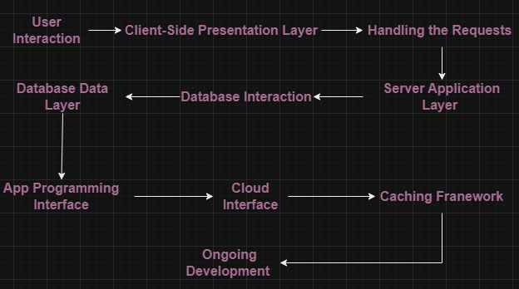Companies keep a close eye on these modifications to make sure they meet the changing needs of performance and scalability *[17] [18]*.

### 1.7.2. Role of HTTP and HTTPS in securing communication between clients and servers

The World Wide Web's data transfer infrastructure is built on HTTP and HTTPs. It is a request-response protocol in which a client submits a request to a server (often a web browser), and the server provides the requested data in return. This process is managed and organized by the HTTP or HTTPs *[19] [20].*

* HTTP:
  + - Text Transmission: Since HTTP transfers data in plain text, accessible, readable, and unencrypted data is shared between the client and server.
    - Stateless Protocol: The HTTP protocol is stateless, which means that every request a client sends to a server is separate to and independent of earlier ones. Its simplicity makes implementation simple, but it also presents security issues.
  + HTTPs:
    - Security Layer: By utilizing encryption., HTTPS adds a security layer to HTTP. To secure the data transferred between the client and server, it uses TLS (Transport Layer Security) or SSL (Secure Sockets Layer) protocols.
    - Data Encryption: When data is transferred over HTTPS, it is encrypted, making it difficult for attackers to decode the information even if it is intercepted. Encryption plays a vital role in safeguarding sensitive information, including financial data, personal information, and login passwords.
    - TLS (Transport Layer Security) Handshake: A TLS handshake takes place when a client establishes an HTTPS connection with a server. To facilitate secure communication, the client and server agree on encryption techniques, create a secure connection, and exchange keys.

### 1.7.3. Web Application Vulnerabilities

|  |  |  |  |
| --- | --- | --- | --- |
| Vulnerability | Description | Exploitation | Mitigation Measures |
| SQL Injection | The attacker manipulates database queries by inserting malicious SQL code into input fields. | Attackers may modify database queries by entering SQL code into form fields. For instance, changing a login query to get around authentication or obtaining private data. | Use parameterized queries or prepared statements to validate and sanitize user inputs. |
| Command Injection | When malicious commands are injected by an attacker into input fields, the host operating system is forced to execute unauthorized (arbitrary) commands. This is known as command injection. Data loss, system compromise, or illegal access are possible outcomes of this. *[21]* | In fields that communicate with the system shell, attackers enter commands. For example, manipulating with input to run OS instructions and take over the system itself. | Verify and sanitize inputs carefully. Stay clear of directly integrating user input with command execution. Apply the least privilege principle and establish strict access controls to reduce the possible impact of hacked instructions. |
| Cross-Site Scripting XSS | Cross-Site Scripting (XSS) is a problem when an attacker inserts harmful scripts into websites so that users' browsers run them. This gives the attacker the ability to modify the website or steal confidential information or session data. *[22]* | Scripts (like JavaScript) are injected by attackers into user input. The injected scripts run in other users' browsers when they load the infected page, which may allow session cookies or private data to be stolen. | To stop script injection, employ input validation and sanitize user inputs. Control script sources by using Content Security Policy (CSP) headers. Before output data arrives in web pages, encode it. |
| Cross-Site Request Forgery (CSRF) | is a misleading attack in which an attacker manipulates a user's browser to accidentally execute commands on a web application that the user has been granted access to. This manipulation takes place without the user's permission and can cause them to operate in an unapproved capacity. *[23]* | Malicious requests are created by attackers and are carried out through the victim's authenticated session. The request is issued if the victim is m is led into loading an image or clicking on a link, which could lead to actions like altering account settings or performing illegal transactions. | In order to make forms more difficult for attackers to exploit, include unpredictable parameters. To limit transmission to the same domain, use the SameSite flag in cookies. As server-side security, use anti-CSRF tokens and validate requests by comparing the values of concealed tokens with session variables. Use security tools for vulnerability identification and codebase analysis, such as GuardRails. To maintain strong protection against CSRF threats, development and security personnel undergo regular training. |

## 1.8. Metasploit:

### 1.8.1. Overview of Metasploit:

Metasploit is a critical open-source hacking and ethical hacking platform that provides security professionals with a comprehensive toolbox of offensive and defensive cybersecurity approaches. This flexible platform includes an extensive number of tools, libraries, and modules that make the challenging process of hacking easier. Metasploit enables users to find and enhance vulnerabilities by configuring exploits and launching attacks with a range of payloads. Cybersecurity professionals from a number of businesses prefer it because of its modular design, which ensures flexibility *[24].*

Metasploit is used in penetration tests to find vulnerabilities by integrating with reconnaissance tools during the information gathering phase. Users can penetrate target systems by picking relevant exploits and payloads. A successful exploit execution offers users interactive access to a shell. Metasploit, in addition to its penetration testing usefulness, plays an important role in proactively detecting and fixing vulnerabilities, making it an indispensable tool for network security professionals, system administrators, and product vendors alike *[24].*

### 1.8.2. Metasploit Components:

* MSFconsole:

Metasploit's main command-line interface, which allows users to scan for vulnerabilities, conduct network reconnaissance, and run attacks.

Real-world scenario: During a penetration test, a cybersecurity expert uses MSFconsole to examine a network for weaknesses. When they find a server that isn't patched, they start certain exploits to see how secure the system is.

* Modules for Exploitation:

Use a range of exploits to target specific vulnerabilities, such as buffer overflows and SQL injections. Each module has a harmful payload for carrying out attacks.

Real-world scenario: A security team uses the exploit modules in Metasploit to simulate an attack and show the possible consequences of a real-world exploit in order to evaluate the risk.

* Extra Modules:

Perform additional penetration-testing tasks like fuzzing, scanning, and denial-of-service (DoS) attacks that are unrelated to direct vulnerability exploitation.

Real-world scenario: Network scanning in order to identify open ports and possible entry points prior to a penetration test. Having this information helps create a well-thought-out plan.

* Post-exploitation Modules:

Provide features like hash dumping, network probing, and application enumeration to expand access on target systems and linked networks.

Real-world scenario: Uses post-exploitation modules to obtain sensitive data after successfully breaching a system. This helps the business strengthen its defenses by highlighting the possible vulnerabilities of a compromised system.

* Modules for payloads:

After a successful intrusion, provide shell code that is run. You can even give sophisticated options like Meterpreter or static scripts to create custom DLLs or increase the capabilities of your exploits.

Real-world scenario: Highlights the effects of a successful attack by utilizing Metasploit's payload modules. This involves demonstrating the process by which an attacker could take over a compromised system.

* No Operation Generator (NOPS):

Produces random bytes to enhance intrusion detection and prevention system (IDS/IPS) evasion by padding buffers.

Real-world scenario: A cybersecurity expert uses NOPS to create random bytes to avoid intrusion detection, hence padding buffers during an assault. This demonstrates a workable way to get around detection measures.

* Store of Data:

A central configuration that defines the behavior of Metasploit components, enabling reuse and dynamic parameter setting across modules and payloads. There is a global datastore as well as module-specific datastores.

### 1.8.3. Metasploit Modules:

The core (the heartbeat) of Metasploit's flexibility, modules are divided into three categories: post-exploitation features, auxiliary tools, and exploits. Their modular design enables focused evaluations and tactical implementation, showcasing the framework's versatility in a range of situations.

### 1.8.4. Metasploit Payloads:

Metasploit's ability in payloads is what makes it so powerful. Payloads are the tools penetration testers, hackers, and ethical hackers use to expand their reach after exploitation and customize their strategy to the particular requirements of each engagement. They can range from simple scripts to sophisticated Meterpreter choices.

### 1.8.5. Metasploit Exploits:

Security experts use Metasploit's vast exploit collection as their toolkit. Whether they reveal vulnerabilities via SQL injections or buffer overflows, exploits are the main toolkit that makes it possible to conduct methodical evaluations of system security.

### 1.8.6. Metasploit Auxiliary Modules:

These modules serve additional functions that are essential for thorough penetration testing, going beyond direct vulnerabilities. These modules broaden the testing environment, guaranteeing a comprehensive assessment of security measures, with capabilities ranging from scanning and fuzzing to simulated denial-of-service scenarios.

### 1.8.7. Metasploit Post-Exploitation Modules:

Following successful exploitation, post-exploitation modules are implemented. Designed to expand access, these modules make tasks like data extraction and network enumeration easier, giving cybersecurity specialists the knowledge, they need to strengthen digital defenses.

### 1.8.9. Ethical Implications:

Although Metasploit is a powerful tool, it must be used responsibly. Making sure that its powers are used for good., like finding and fixing vulnerabilities, as opposed to evil intent, is one of the ethical considerations. Upholding moral standards is crucial for security professionals, who must emphasize the significance of consent, transparency, and responsible disclosure in their work.

The improvements concentrate on giving the descriptions greater precision and clarity while presenting a more sophisticated synopsis of each component's function within Metasploit. Furthermore, ethical considerations are stressed to provide a thorough grasp of responsible tool use.

# 2. Reconnaissance and vulnerability analysis phase

## 2.1. Passive Information Gathering on Crispy Chicken Website

### 2.1.1. The used tools for passive information:

* + - NetCraft.
    - goBuster.
    - Manual scanning.
    - WHOIS. “website”
    - dmitry -i 46.30.215.202 (When utilizing Dmitry, it is usual to provide the destination IP address or domain with the "-i" parameter.)

### 2.1.2. Analysis on the gathered information:

* + - Website Overview:

Delve into the dynamic realm of crispychicken.rest, residing within the hosting infrastructure of one.com Group in Denmark (IP: 46.30.215.202).

Ascio Technologies Inc. orchestrated the registration of the domain on May 15, 2017, opting for the sophisticated Rest (.rest) top-level domain, with an expiration set for May 15, 2024.

* + - Netcraft Information:

The website, which made its debut on the internet in January 2019, is delighted to have a 1/10 Netcraft Risk Rating.

* + - SSL/TLS Certificate:

The website has been strengthened with a Let's Encrypt SSL/TLS certificate, which builds up its security architecture and extends its protective embrace from November 24, 2023, to February 22, 2024.

Using the state-of-the-art TLS_AES_256_GCM_SHA384 and TLSv1.3 encryption protocols guarantees full forward secrecy and strong security.

* + - Geolocation:

The website is geographically based in Denmark and its IP address range is 46.30.212.0 to 46.30.215.255, indicating that it is a regional presence.

* + - WHOIS Information:

The website's digital identity is under the control of Hamburg International Restaurants Co., which has its headquarters located in Jordan (JO).

Specific contact information for administrative, technical, and registrant entities is kept private while adhering to privacy guidelines.

* + - Web Trackers:

Working with accuracy, a single tracker—Google—acts as the CDN tracker, incorporating necessary tracking features into the website.

* + - Site Technology:

The website's smart usage of Varnish, a powerful HTTP accelerator, and PHP on the server side highlight its technological acumen.

Client-side technologies like JavaScript and jQuery work together to improve the user experience, and the trustworthy WordPress platform orchestrates all of this.

* + - Security Information:

The website creates a strong defense against the Heartbleed exploit.

and purposefully stays away from SSL version 3 (SSLv3), demonstrating a dedication to strong security measures.

The website maintains a great security posture; nonetheless, it is noteworthy that neither SPF nor DMARC records are present. This gives a complete picture of the security landscape of the website.

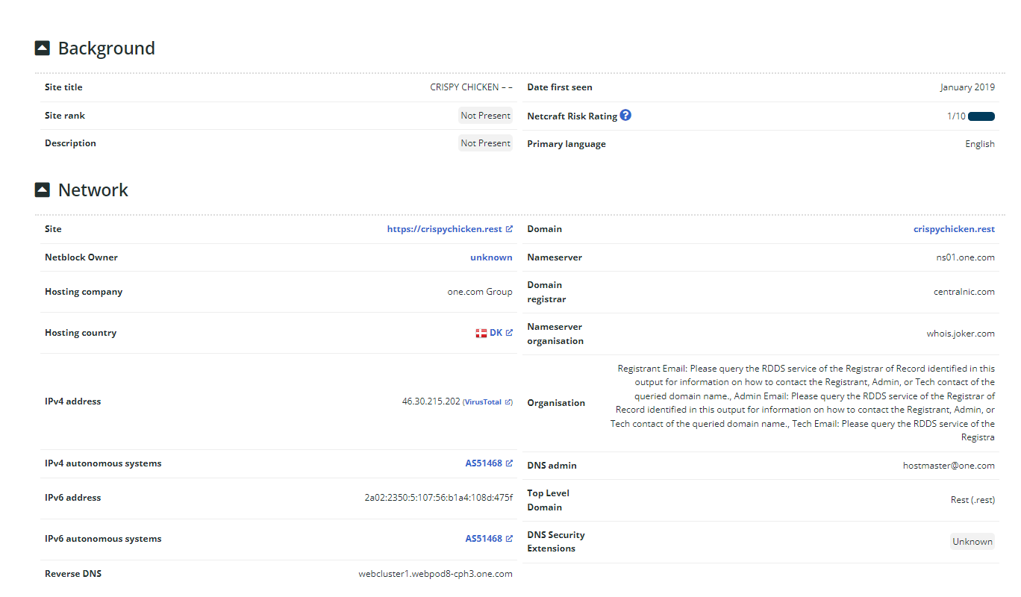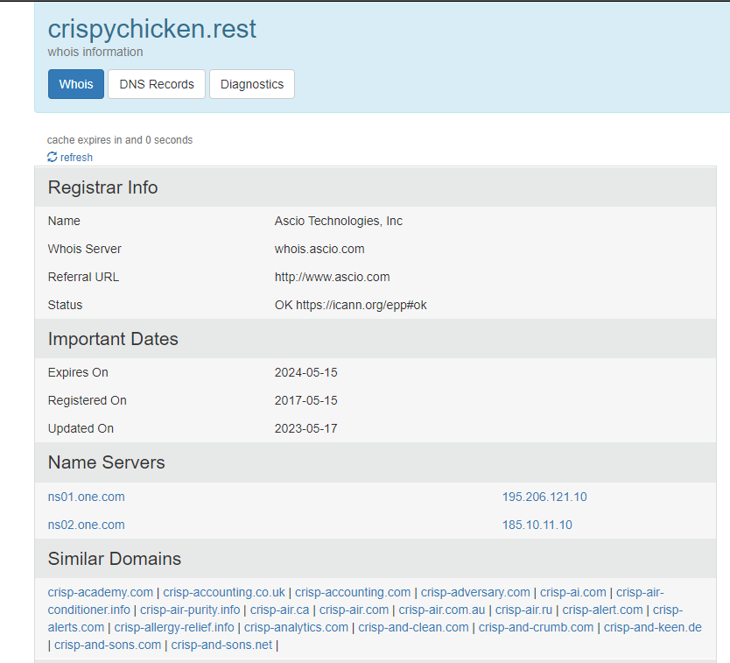

Hamza Osama

Hamza Osama

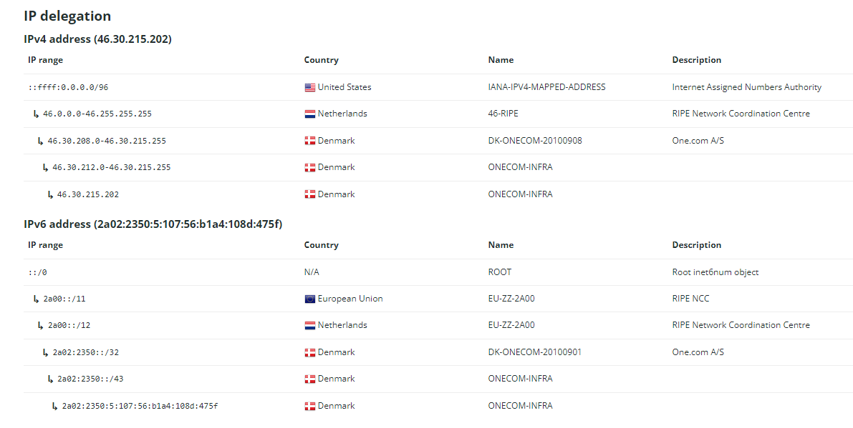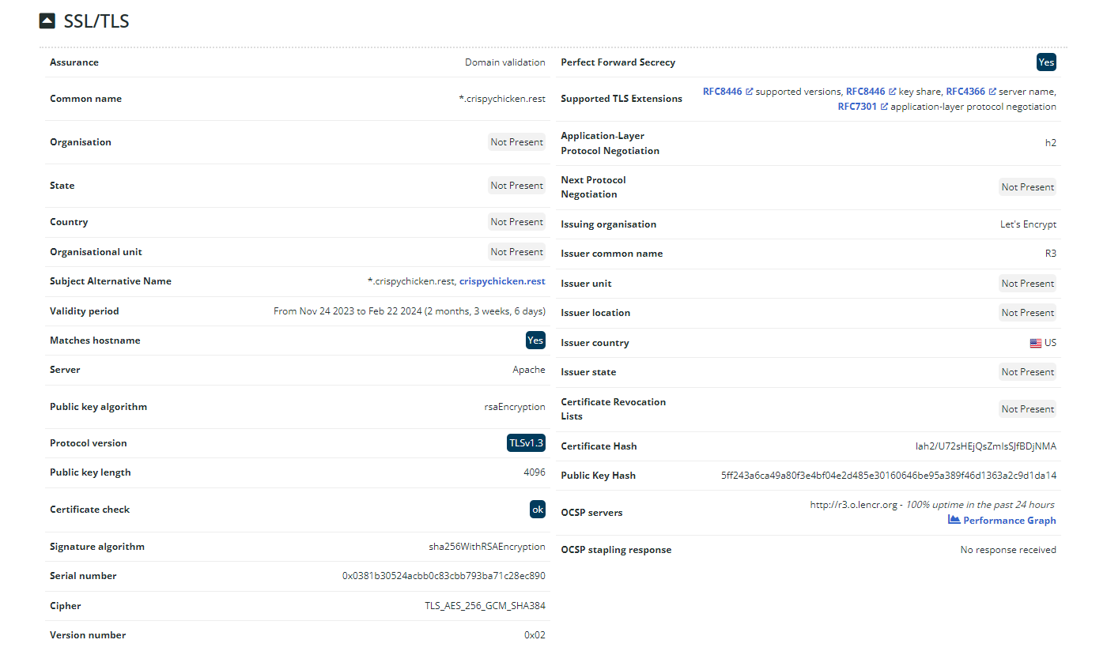

Hamza Osama

Hamza Osama

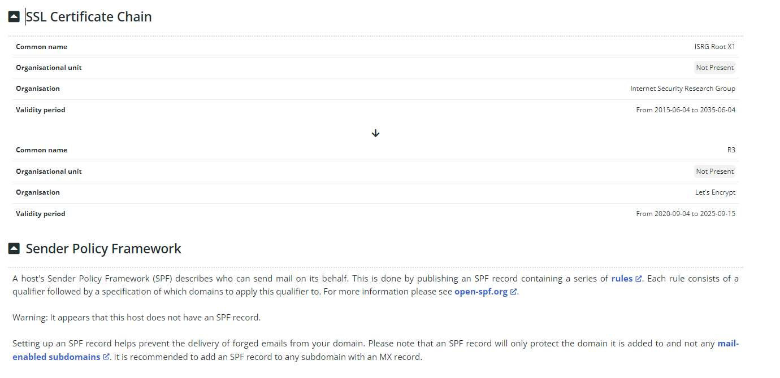

Hamza Osama

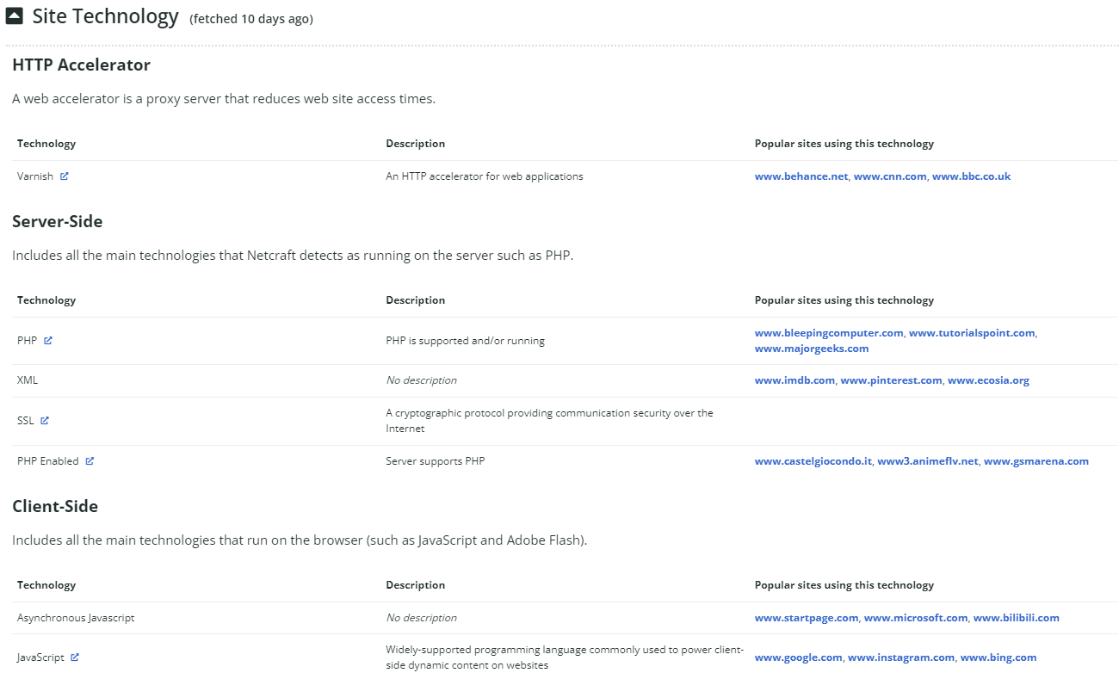

Hamza Osama

Hamza Osama

Hamza Osama

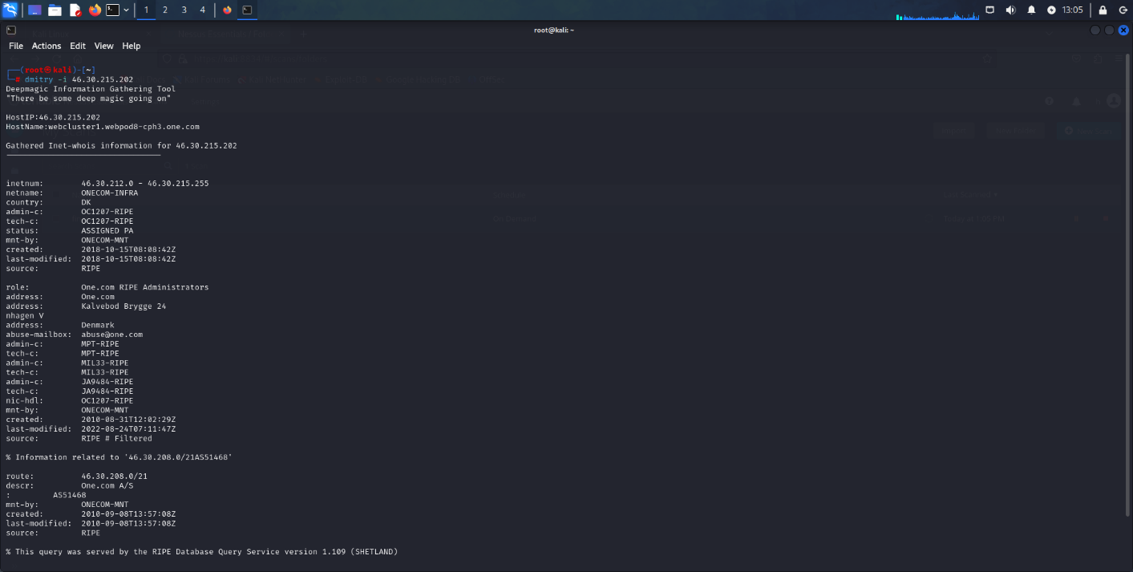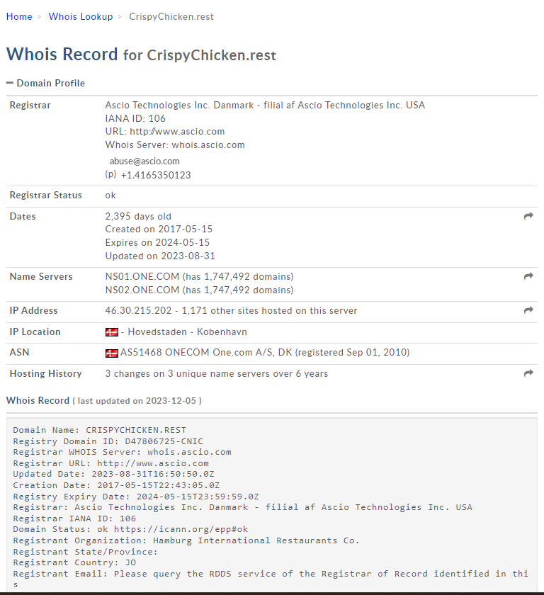

## 2.2. Active Scanning:

### 2.2.1. The used tool and command:

I used namp and with this command nmap -p- -sV -O -T4 192.168.0.193

“-p-” Scanning every 65,535 port.

“-sV” Allows for the detection of the versions of services that are currently running.

“-O” Identifies the target's operating system by performing OS detection.

“-T4” Indicates that the timing template is "Aggressive." It regulates the scan's speed, and T4 is a comparatively quick choice.

### 2.2.2. Table Containing the Unique Data from the Nmap Scan:

|  |  |  |  |  |
| --- | --- | --- | --- | --- |
| *Port* | *State* | *Service* | *Version* | *OS* |
| 23 | open | telnet | Microsoft Windows XP telnetd | Windows XP |
| 80 | open | http | Apache httpd 2.4.16 ((Win32) OpenSSL/1.0.1p PHP/5.6.11) | Windows 7 SP0 - SP1, Server 2008 SP1, Server 2008 R2, Windows 8, Windows 8.1 Update 1 |
| 135 | open | msrpc | Microsoft Windows RPC | ---------------------------------------- |
| 139 | open | netbios-ssn | Microsoft Windows netbios-ssn | ---------------------------------------- |
| 443 | open | ssl/http | Apache httpd 2.4.16 ((Win32) OpenSSL/1.0.1p PHP/5.6.11) | ---------------------------------------- |
| 445 | open | microsoft-ds | Microsoft Windows Server 2008 R2 - 2012 microsoft-ds | ---------------------------------------- |
| 3306 | open | mysql | MySQL 5.6.25 | ---------------------------------------- |
| 3389 | open | ssl/ms-wbt-server? |  | ---------------------------------------- |
| 47001 | open | http | Microsoft HTTPAPI httpd 2.0 (SSDP/UPnP) | ---------------------------------------- |
| 49152 | open | msrpc | Microsoft Windows RPC | ---------------------------------------- |
| 49153 | open | msrpc | Microsoft Windows RPC | ---------------------------------------- |
| 49154 | open | msrpc | Microsoft Windows RPC | ---------------------------------------- |
| 49155 | open | msrpc | Microsoft Windows RPC | ---------------------------------------- |
| 49156 | open | msrpc | Microsoft Windows RPC | ---------------------------------------- |
| 49157 | open | msrpc | Microsoft Windows RPC | ---------------------------------------- |
| 49159 | open | msrpc | Microsoft Windows RPC | ---------------------------------------- |

### 2.2.3. Summary of Nmap Table:

Active Scanning Analysis:

* + - Host Information:
    - IP Address: 192.168.0.193
    - MAC Address: 08:00:27:0E:37: F1 (Oracle VirtualBox virtual NIC)
    - Device Type: General purpose
    - Open Ports and Services:
    - Notable services include Telnet (port 23).
    - HTTP (port 80 and 443).
    - Microsoft RPC (port 135 and others).
    - NetBIOS (port 139), MySQL (port 3306).
    - Microsoft-DS (port 445).
    - Operating System Information:

Detected operating systems include Microsoft Windows XP, Windows 7, Windows Server 2008 R2 - 2012, and Windows 8.1.

* + - Service Versions:

Versions of specific services are identified, such as Apache httpd 2.4.16, OpenSSL/1.0.1p, PHP/5.6.11, and MySQL 5.6.25.

* + - Network Distance:

The target is one hop away.

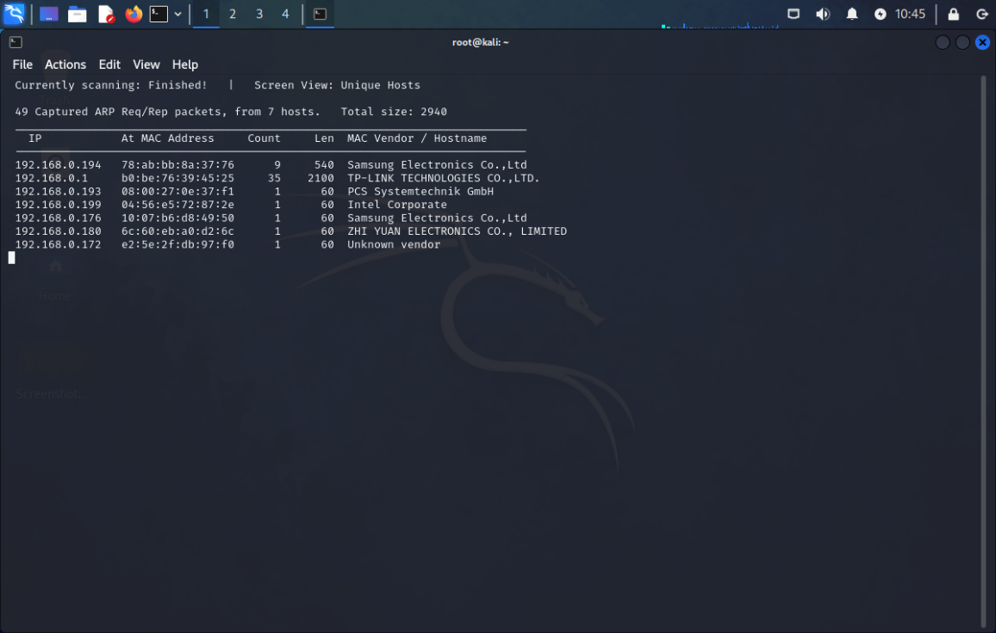

Hamza Osama

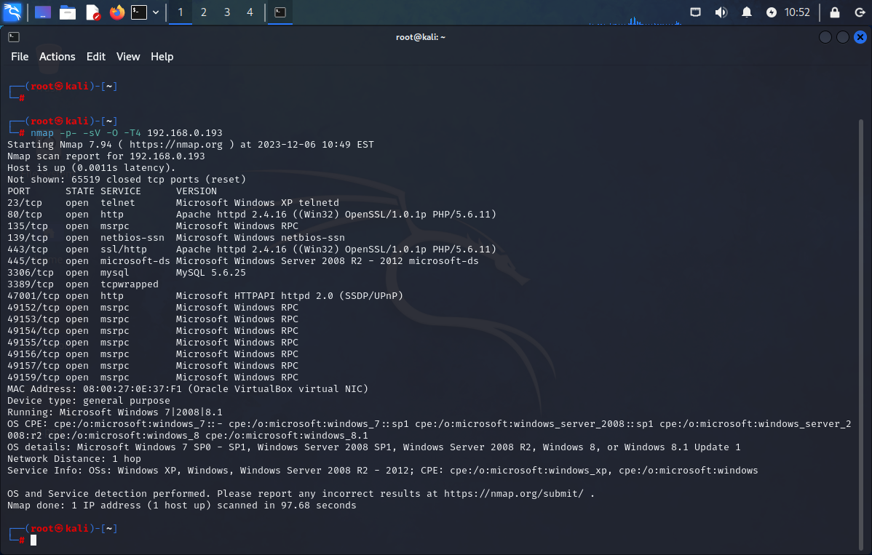

Hamza Osama

## 2.3. Vulnerability Assessment:

### 2.3.1. The used tools for vulnerability assessment:

Nessus

### 2.3.2. Table contains the results of vulnerability assessment:

|  |  |  |  |  |
| --- | --- | --- | --- | --- |
| *Vulnerability ID* | *Description* | *Severity Level* | *Affected Systems* | *Mitigation Recommendations* |
| MS17-010 (ETERNALBLUE) | Microsoft SMBv1 has multiple vulnerabilities that allow for information exposure and remote code execution. Petya, WannaCry., and EternalRocks exploited. | Critical | Windows Vista, 7, 8.1, 10, Server 2008, 2012, 2016, XP, 8 | Apply Microsoft patches for supported systems. - Discontinue use of SMBv1 for unsupported systems. - Block TCP port 445 for SMB on network devices. - For SMB over NetBIOS., block TCP ports 137/139 and UDP ports 137/138. |
| Unsupported Windows OS | Windows Server 2008 R2 Enterprise SP1 is not supported. out of date or missing service pack, probably with security flaws | High | Windows Server 2008 R2 Enterprise SP1 | Upgrade to a supported service pack or operating system. |
| SSL Certificate Weak Hash | SSL certificate chain signed using weak hashing algorithm (MD2., MD4, MD5, or SHA1). Vulnerable to collision attacks. | Medium | 192.168.0.193 | Contact the Certificate Authority to reissue the SSL certificate. |
| OpenSSL 1.0.1 < 1.0.1t | Multiple vulnerabilities in OpenSSL 1.0.1. Includes heap buffer overflow., padding oracle attack, and out-of-bounds read errors. | High | Systems using OpenSSL 1.0.1 prior to 1.0.1t | Upgrade to OpenSSL version 1.0.1t or later. |
| OpenSSL < 1.0.2i (SWEET32) | vulnerability in the Blowfish and 3DES algorithms, which by default use weak 64-bit block encryption. permits a man-in-the-middle attacker with ample resources to launch a "birthday" attack. | High | Systems using OpenSSL prior to 1.0.2i | Upgrade to OpenSSL version 1.0.2i or later. |
| MS12-020 (uncredentialed check) | RDP on Windows has an uncontrolled remote code execution vulnerability. permits the use of customized RDP packets to execute arbitrary code. | Critical | Windows XP, 2003, Vista, 2008, 7, 2008 R2 | Install the latest Microsoft updates. Examine whether "Allow connections only from computers running Network Level Authentication with Remote Desktop" is enabled. Set the security layer of the remote host to 'SSL (TLS 1.0)'. |
| PHP 5.6.x < 5.6.37 exif_thumbnail_extract() DoS | Denial of service vulnerability in PHP 5.6.x prior to 5.6.37. | High | Systems running PHP 5.6.x prior to 5.6.37 | Upgrade PHP version. |
| Apache 2.4.x < 2.4.25 (httpoxy) | Multiple vulnerabilities in Apache 2.4.x prior to 2.4.25, including: - Encryption flaw in mod_session_crypto (CVE-2016-0736) - DoS in mod_auth_digest (CVE-2016-2161) - httpoxy MITM vulnerability (CVE-2016-5387) - DoS in mod_http2 (CVE-2016-8740) - User-agent header flaw (CVE-2016-8743) - CRLF injection for HTTP response splitting (CVE-2016-4975) | High | Apache 2.4.x prior to 2.4.25 | Ensure affected modules (mod_session_crypto, mod_auth_digest, and mod_http2) are not in use. And Upgrade Apache server. |
| Apache 2.4.x < 2.4.52 mod_lua Buffer Overflow | When handling multipart material, Apache httpd prior to 2.4.52 has a bug linked to mod_lua. Crafted requests can trigger a buffer overflow in the mod_lua multipart parser, potentially allowing for exploitation. | Critical | Apache 2.4.x prior to 2.4.52 | Upgrade Apache server. |
| Unencrypted Telnet Server | The remote host is running a Telnet server over an unprotected connection. It is not recommended to utilize Telnet over an unencrypted channel since commands, login passwords, and other data are transferred in cleartext, making interceptions possible. | High | Telnet service running on port 23 | Disable the Telnet service and use SSH instead. |
| SMB Signing not required | The remote SMB server does not require signing. An unauthenticated, remote attacker can take advantage of this to launch man-in-the-middle attacks on the SMB server. | Medium | SMB service running on port 445 | Message signing should be required in the host configuration. This information is contained in the policy option 'Microsoft network server: Digitally sign communications (always)' on Windows. On Samba, this is referred to as "server signing. |
| TLS Version 1.0 Protocol Detection | The remote service accepts TLS 1.0 encrypted connections. TLS 1.0 contains cryptographic architecture flaws. These concerns are mitigated by modern TLS 1.0 implementations, however TLS 1.2 and 1.3 are designed to be resistant to these flaws and should be used wherever possible. | Medium | RDP service running on port 3389 and HTTPS service running on port 443 | Enable support for TLS 1.2 and 1.3, and disable support for TLS 1.0. |
| Terminal Services Doesn't Use Network Level Authentication (NLA) Only | The remote Terminal Services is not set up to use solely Network Level Authentication (NLA). NLA employs the Credential Security Support Provider (CredSSP) protocol to perform robust server authentication using TLS/SSL or Kerberos protocols, hence preventing man-in-the-middle attacks. In addition to enhancing authentication, NLA protects the remote machine against fraudulent users and software by completing user authentication before establishing a full RDP connection. | Medium | RDP service running on port 3389 | Enable Network Level Authentication (NLA) on the remote RDP server. |
| SSL Certificate Cannot Be Trusted | The server's X.509 certificate is untrustworthy. In this scenario, three things could happen: 1) The certificate chain's top is not descended from a recognized public certificate authority; 2) The certificate chain contains a certificate that was invalid at the time of the scan; or 3) The certificate chain contains a signature that was either untrustworthy or did not match the information on the certificate. If the remote host is a public host in production, any break in the chain makes it more difficult for users to validate the legitimacy and identity of the web server. As a result, man-in-the-middle attacks on the remote host may be easier to carry out. | Medium | Port 443 (HTTPS) on 192.168.0.193 | Purchase or generate a proper SSL certificate for this service. |
| SSL Certificate Expiry | This plugin examines the expiry dates of certificates linked with SSL-enabled services on the target and reports on any that have already expired. | Critical | Port 443 (HTTPS) on 192.168.0.193 | Purchase or generate a new SSL certificate to replace the existing one. |
| PHP < 7.3.28 Email Header Injection | The version of PHP that is now operating on the remote web server is less than 7.3.28, based on its self-reported version number. As a result of improper handling of CR-LF sequences in header fields, it is vulnerable to email header injection attacks. By adding line feed characters to email headers, an unauthenticated remote attacker can take advantage of this and fully alter the content of email headers. | Critical | Port 80 (HTTP) on 192.168.0.193, Port 443 (HTTPS) on 192.168.0.193 | Upgrade the PHP version. |
| PHP 5.6.x < 5.6.35 Security Bypass Vulnerability | The remote web server is using a version of PHP that is 5.6.x older than 5.6.35, based on its banner. As a result, a security bypass vulnerability affects it. Because fpm_unix.c makes a PR_SET_DUMPABLE prctl call, dumpable FPM child processes enable bypassing opcache access controls. In a multiuser environment, this means that one user can obtain sensitive data from the process memory of another user's PHP applications by running gcore on the PID of the PHP-FPM worker process. | Critical | Port 443 (HTTPS) on 192.168.0.193, Port 80 (HTTP) on 192.168.0.193 | Upgrade the PHP version. |
| PHP 5.6.x < 5.6.33 Multiple Vulnerabilities | The remote web server is using a version of PHP that is 5.6.x older than 5.6.33, based on its banner. Consequently, it is impacted by several vulnerabilities: An incorrect validation of user-supplied input prior to returning it to users may have resulted in a reflected XSS in.phar 404 pages and a potential infinite loop in gdImageCreateFromGifCtx (CVE-2018-5711). By persuading a user to click on a specially crafted URL, an unauthenticated remote attacker can take advantage of this and run arbitrary script code in the user's browser session (CVE-2018-5712). It should be noted that Nessus has solely relied on the application's self-reported version number and has not performed any testing for this vulnerability. | High | Port 443 (HTTPS) on 192.168.0.193, Port 80 (HTTP) on 192.168.0.193 | Upgrade the PHP version. |
| Unsupported Windows OS (remote) | The remote version of Microsoft Windows is either missing a service pack or is no longer supported. As a result, it is likely to contain security vulnerabilities. | High | 192.168.0.193 | Upgrade to a supported service pack or operating system. |
| Microsoft RDP RCE (CVE-2019-0708) (BlueKeep) (uncredentialed check) | The remote host is affected by a remote code execution vulnerability in the Remote Desktop Protocol (RDP). An unauthenticated remote attacker can utilize this to execute arbitrary code via a well-designed sequence of queries. | Critical | 192.168.0.193 | Apply the patches released by Microsoft for Windows XP, 2003, 2008, 7, and 2008 R2 |

### 2.3.2. Security Vulnerability Assessment Summary:

* + - critical Concerns:
    - MS17-010 (ETERNALBLUE):

Risk: Information exposure and remote code execution.

Action: Apply Microsoft patches promptly.

* + - Unsupported Windows OS:

Risk: Windows Server 2008 R2 Enterprise SP1 lacks support.

Action: Urgently upgrade to a supported OS.

* + - MS12-020 (RDP Remote Code Execution):

Risk: Uncontrolled remote code execution in RDP.

Action: Install latest Microsoft updates and ensure NLA is enabled.

* + - High-Impact Findings:
* SSL Certificate Weak Hash:

Risk: SSL certificate vulnerability.

Action: Collaborate with CA for reissuing with robust hashing.

* OpenSSL Vulnerabilities:

Risk: Multiple flaws in OpenSSL.

Action: Upgrade to OpenSSL 1.0.1t or later.

* Urgent PHP and Apache Updates:
* PHP Security Bypass and Multiple Vulnerabilities:

Action: Upgrade PHP to versions 5.6.37 and 7.3.28.

Apache Server Vulnerabilities:

Action: Upgrade Apache servers to versions 2.4.25 or 2.4.52.

* Medium-Impact Focus Areas:
  + Telnet Service:

Action: Disable Telnet; opt for SSH.

* + SMB Signing and TLS Protocol:

Action: Enforce SMB message signing; enable TLS 1.2 and 1.3.

* + Terminal Services and SSL Certificate Trust:

Action: Enable NLA on RDP; obtain a trustworthy SSL certificate.

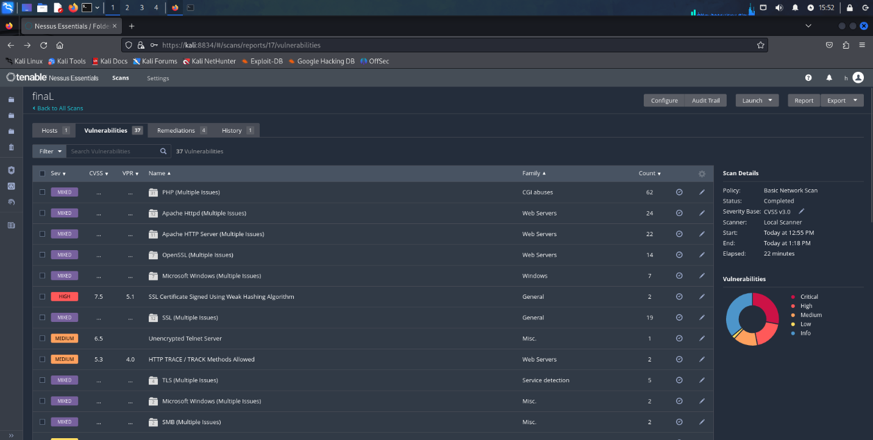

Hamza Osama

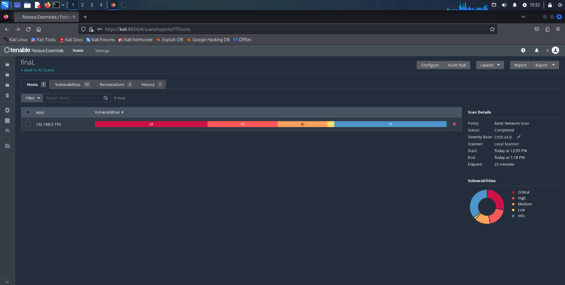

Hamza Osama

# 3. Exploitation phase

## 3.1. Wireshark

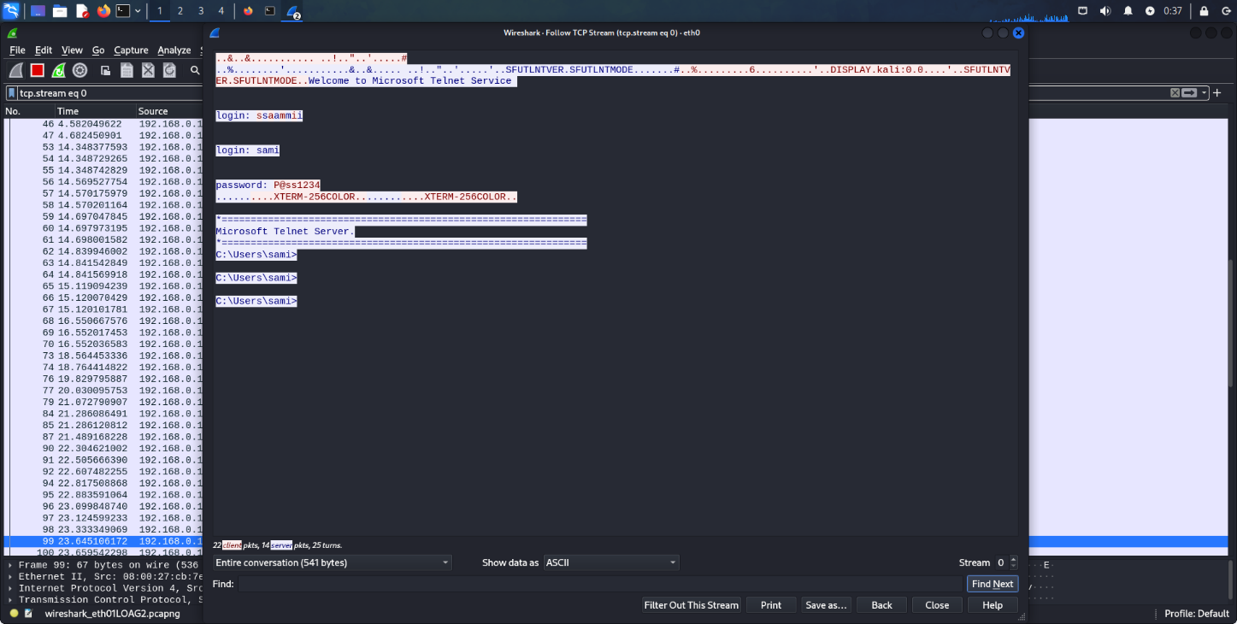

Hamza Osama

## 3.2. Execute a Password Cracking Attack

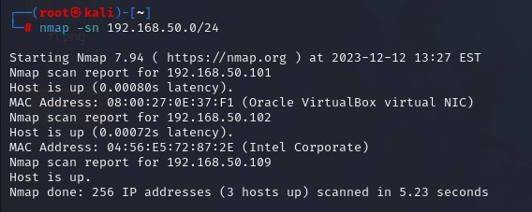

Hamza Osama

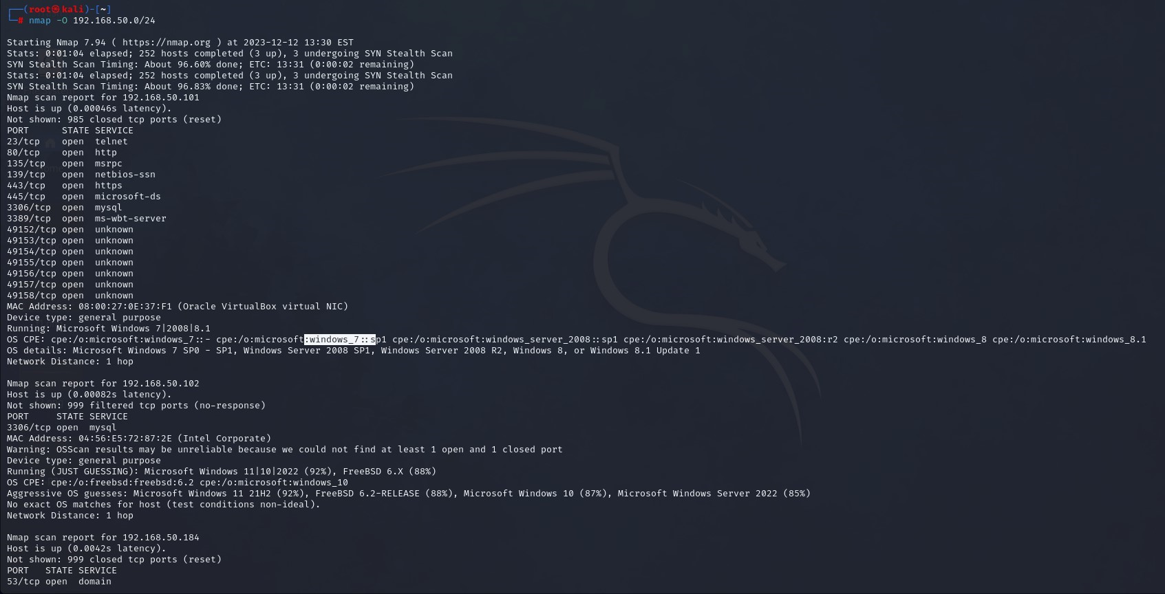

Hamza Osama

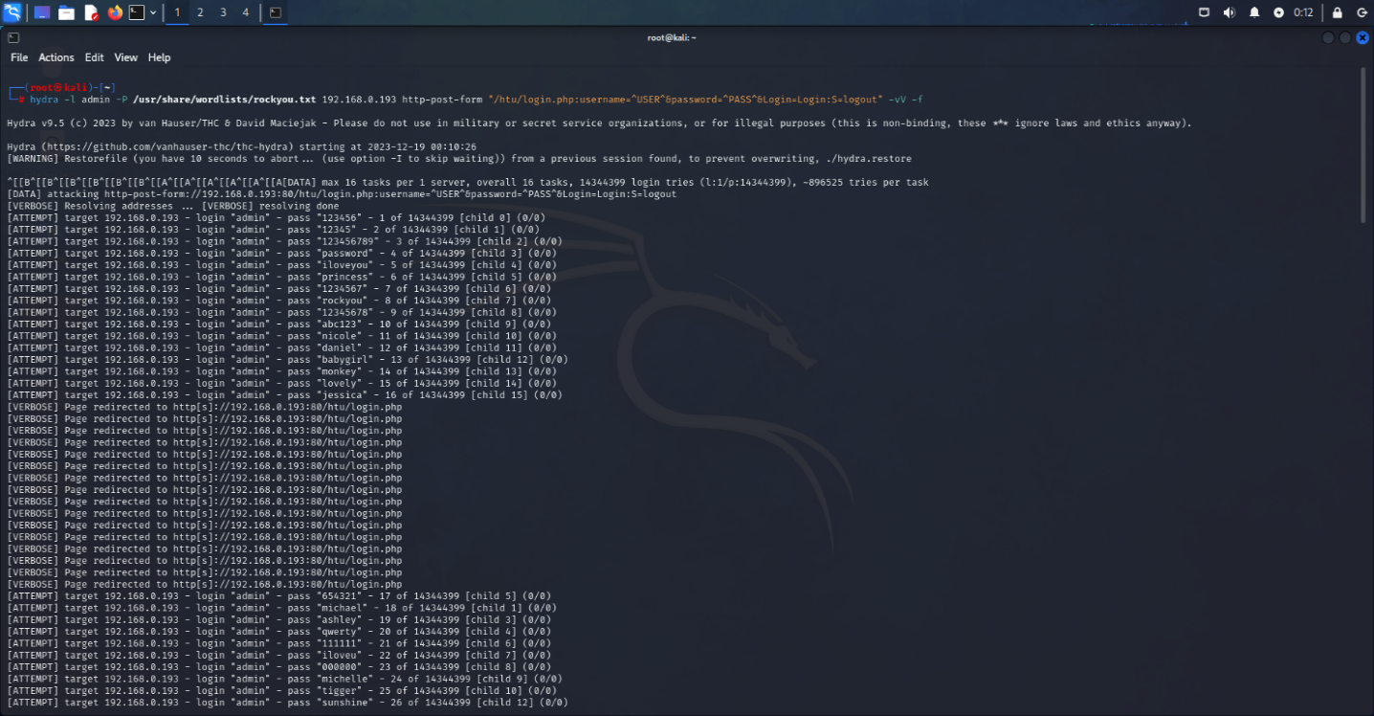

Hamza Osama

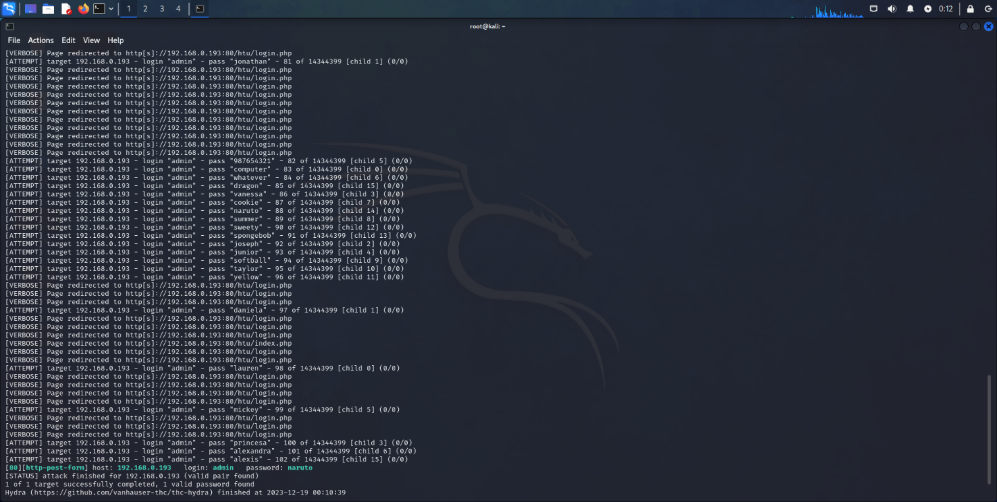

Hamza Osama

## 3.3. Injection Attacks

### 3.3.1. Manual Injection into Login

I used username “admin” with “‘or’1’=’1” in the password



Hamza Osama

### 3.3.2.XXS Vulnerabilities



Hamza Osama

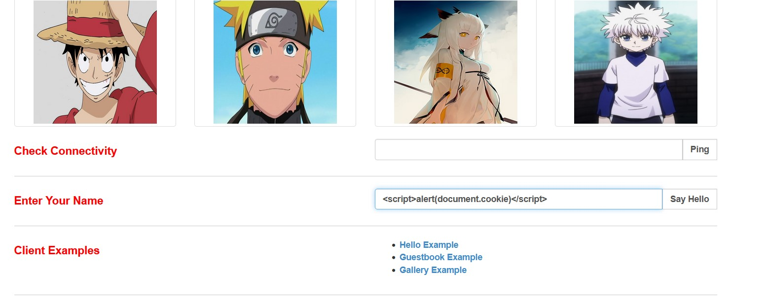

Hamza Osama



Hamza Osama

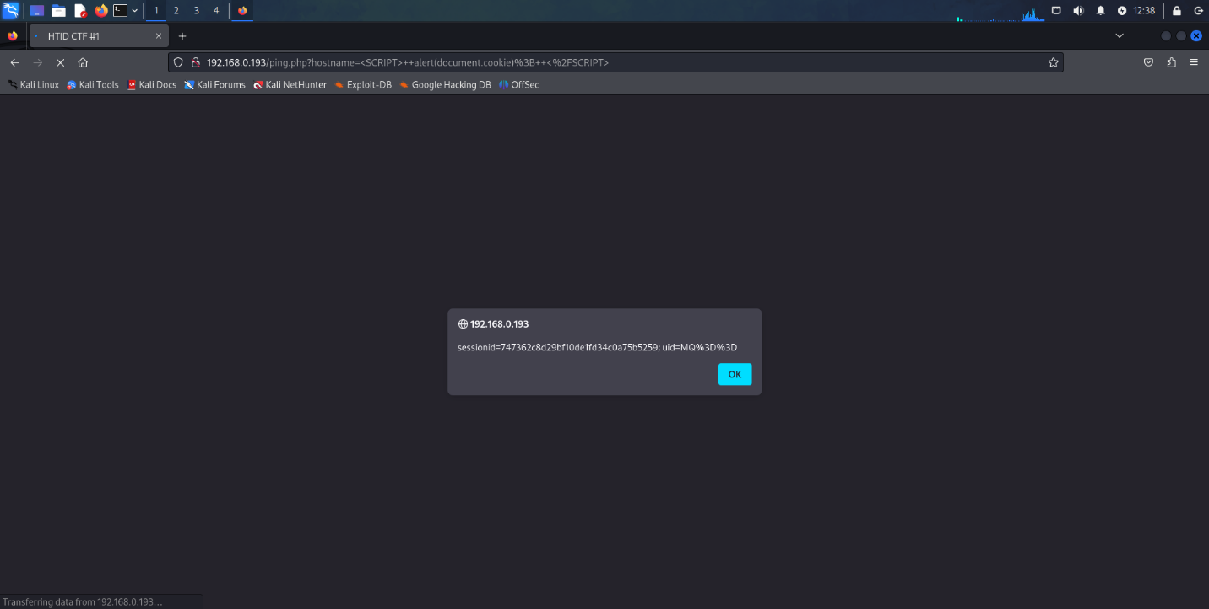

Hamza Osama

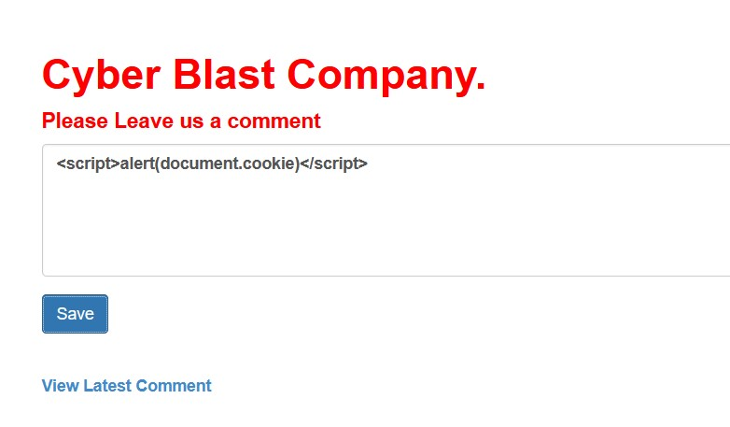

Hamza Osama



Hamza Osama

### 3.3.3. SQLMap

SQLMap to identify the database name, dump the entire database, and obtain an OS shell.

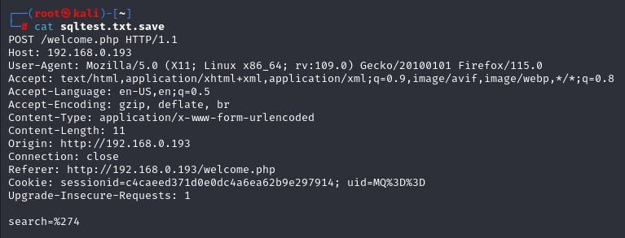

Hamza Osama

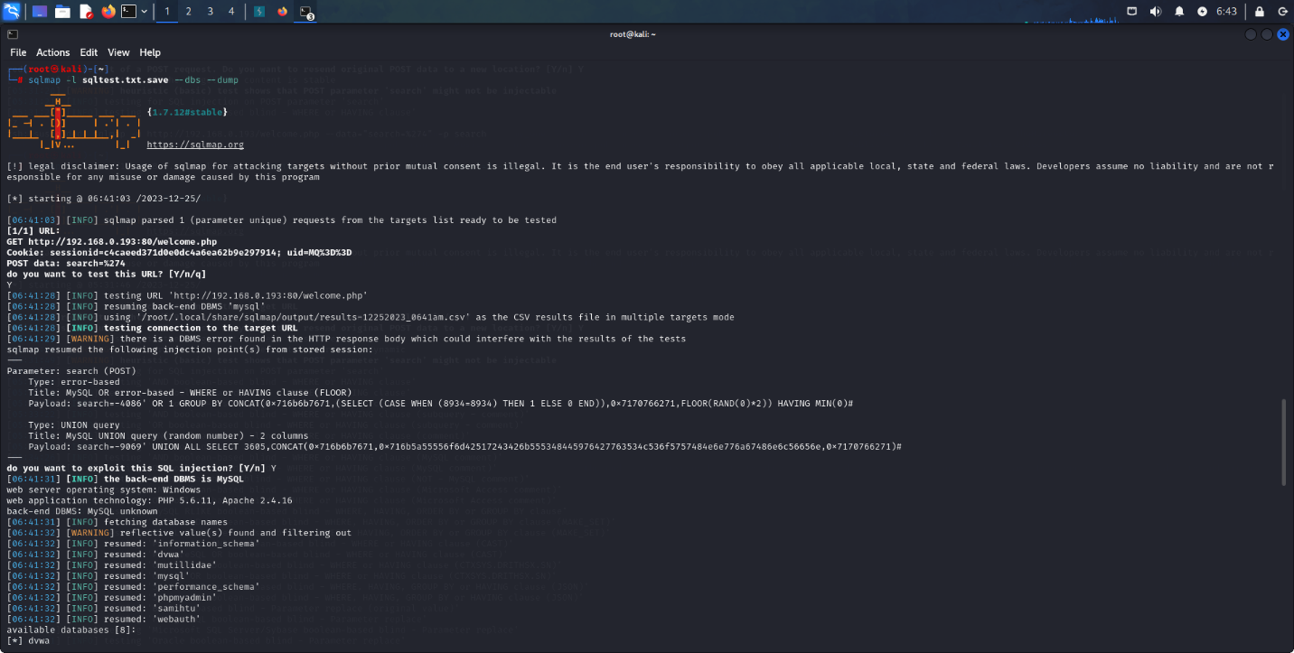

Hamza Osama

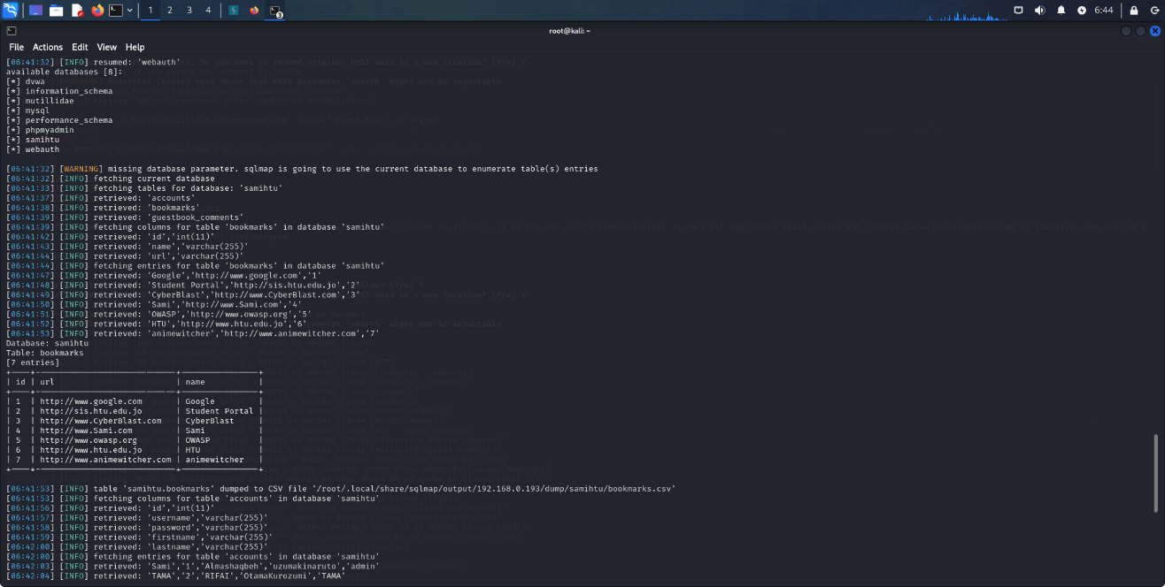

Hamza Osama

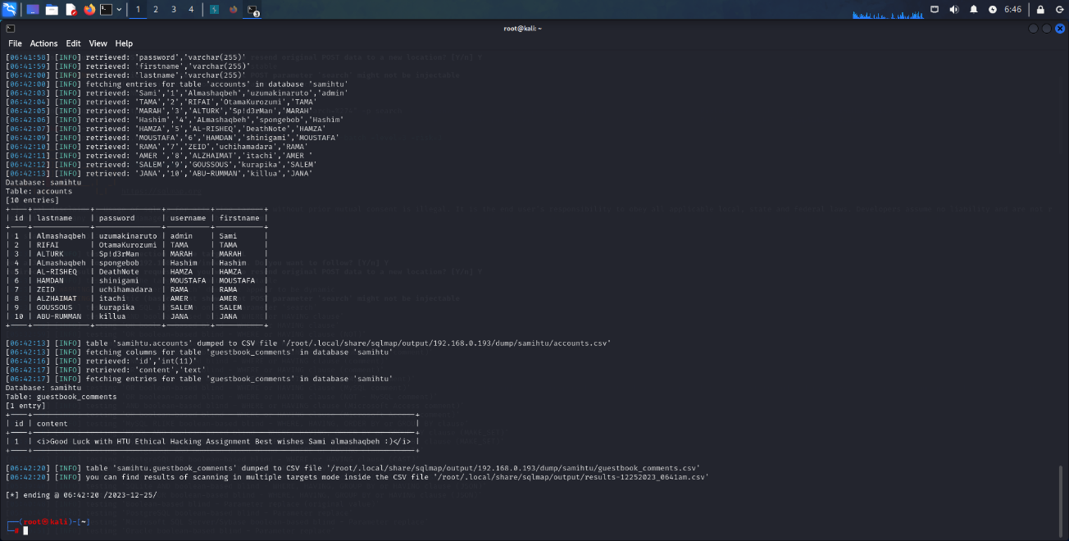

Hamza Osama

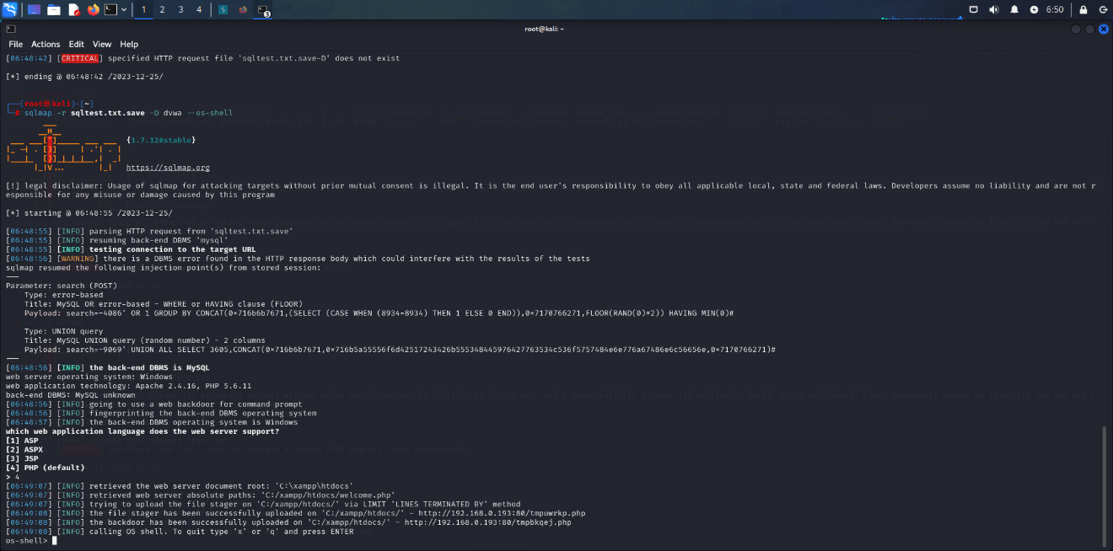

Hamza Osama

### 3.3.4. Command Injection

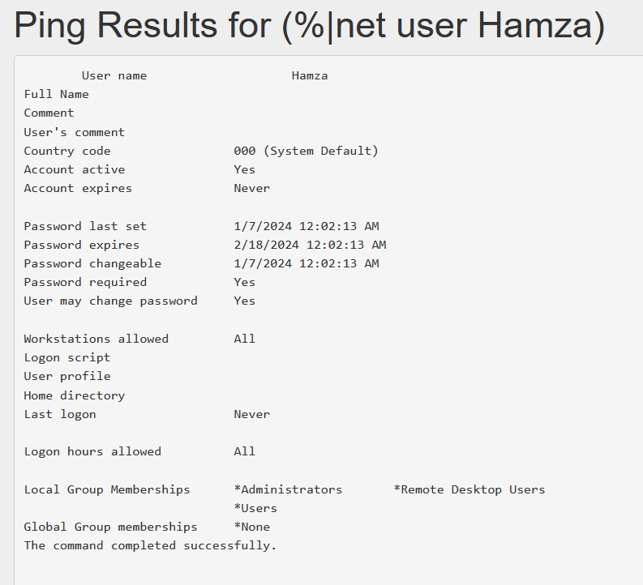

Hamza Osama

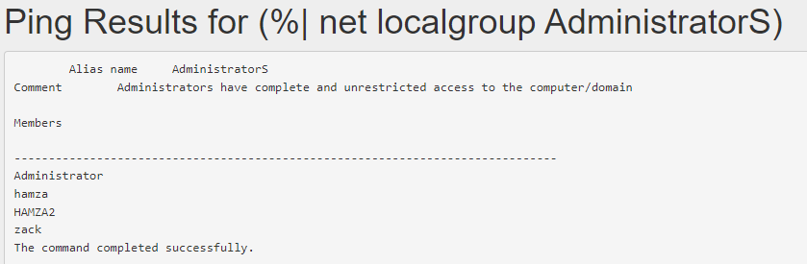

Hamza Osama

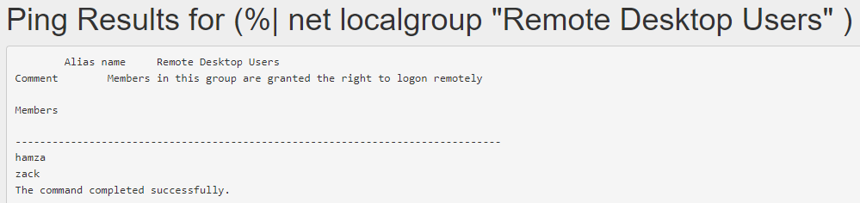

Hamza Osama

### 3.3.5. Manual SQL Approach

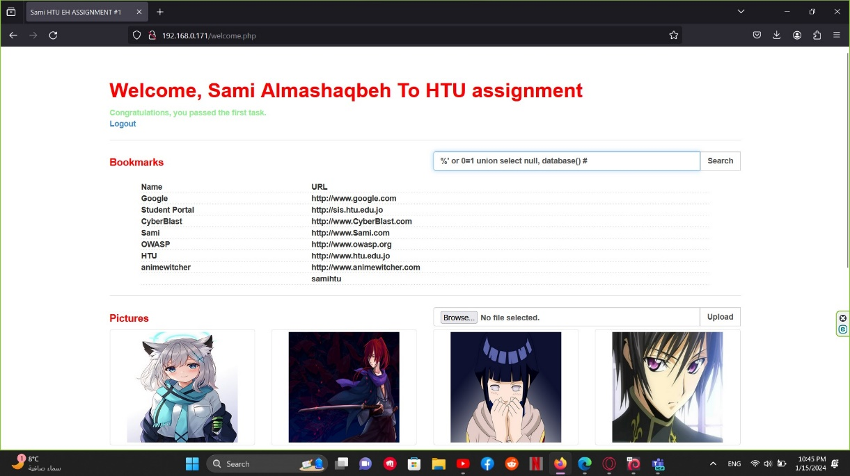

Hamza Osama

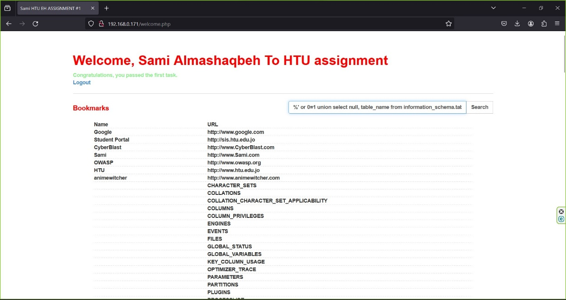

Hamza Osama



Hamza Osama

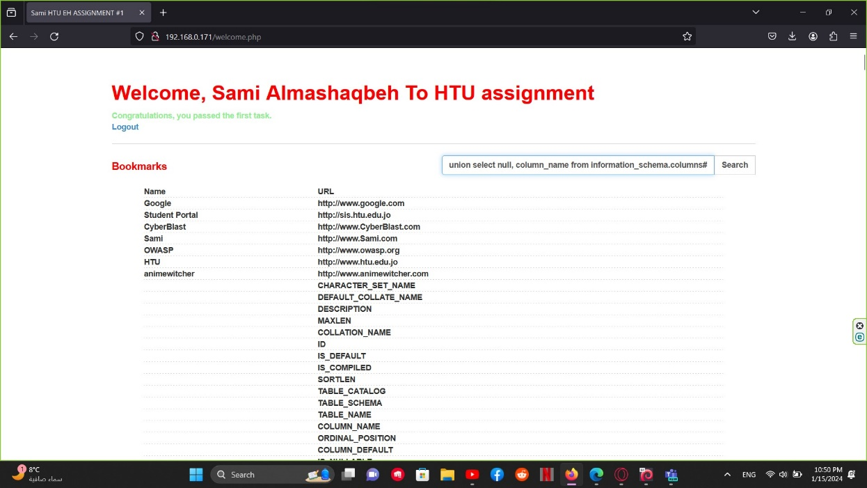

Hamza Osama

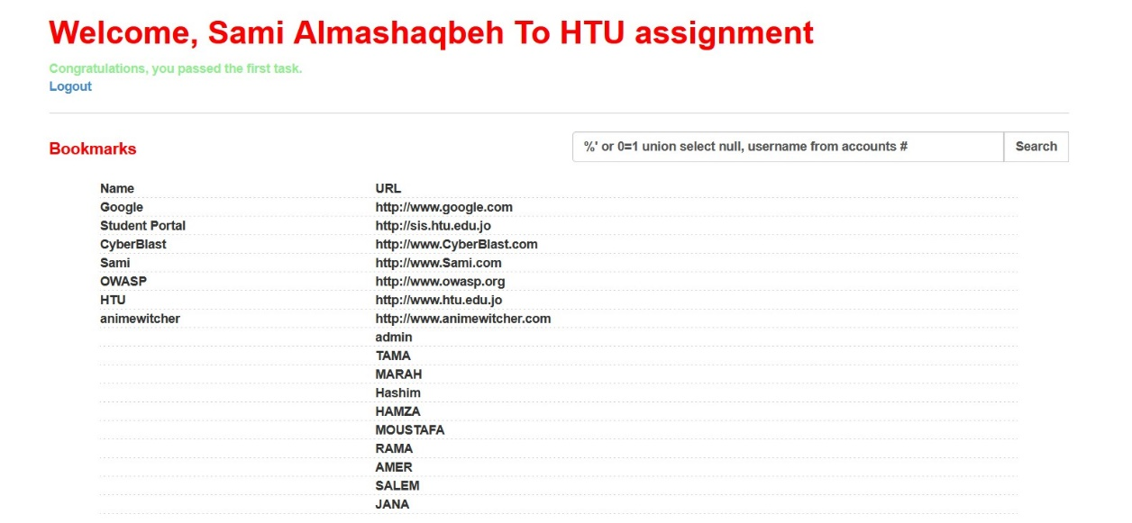

Hamza Osama

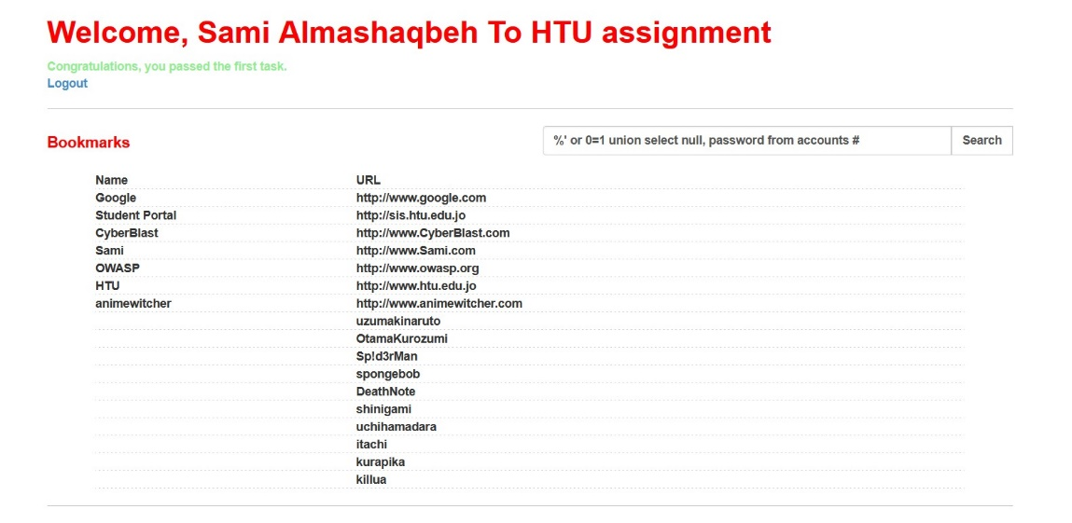

Hamza Osama

Accounts table:

|  |  |
| --- | --- |
| *Username* | *Password* |
| admin |  |
| TAMA | OtamaKurozumi |
| MARAH | Sp!d3rMan |
| Hashim | spongebob |
| HAMZA | DeathNote |
| MOUSTAFA | shinigami |
| RAMA | uchihamadara |
| AMER | itachi |
| SALEM | kurapika |
| JANA | killua |

## 3.4. Some of OWASP Top 10 vulnerabilities as follows

3.4.1. Broken Authentication and Session Management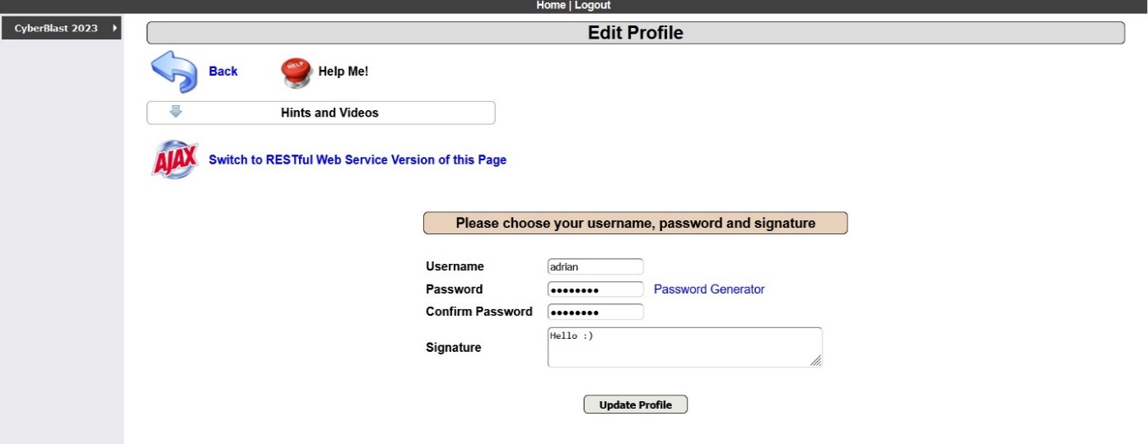

Hamza Osama

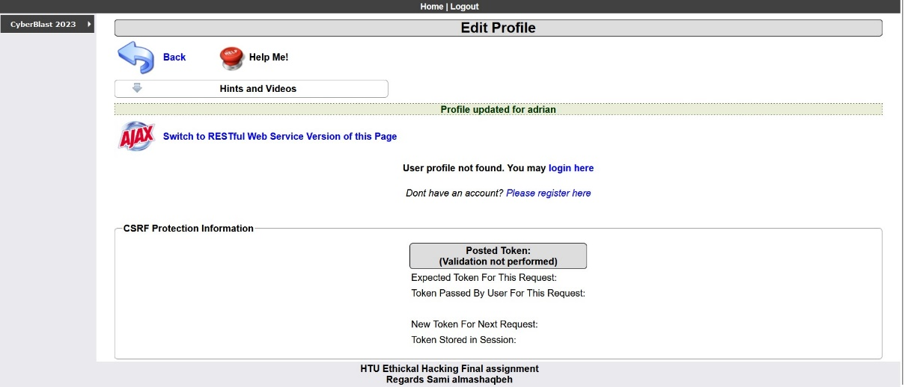

Hamza Osama

3.4.2. Discover the database password and Sami's comments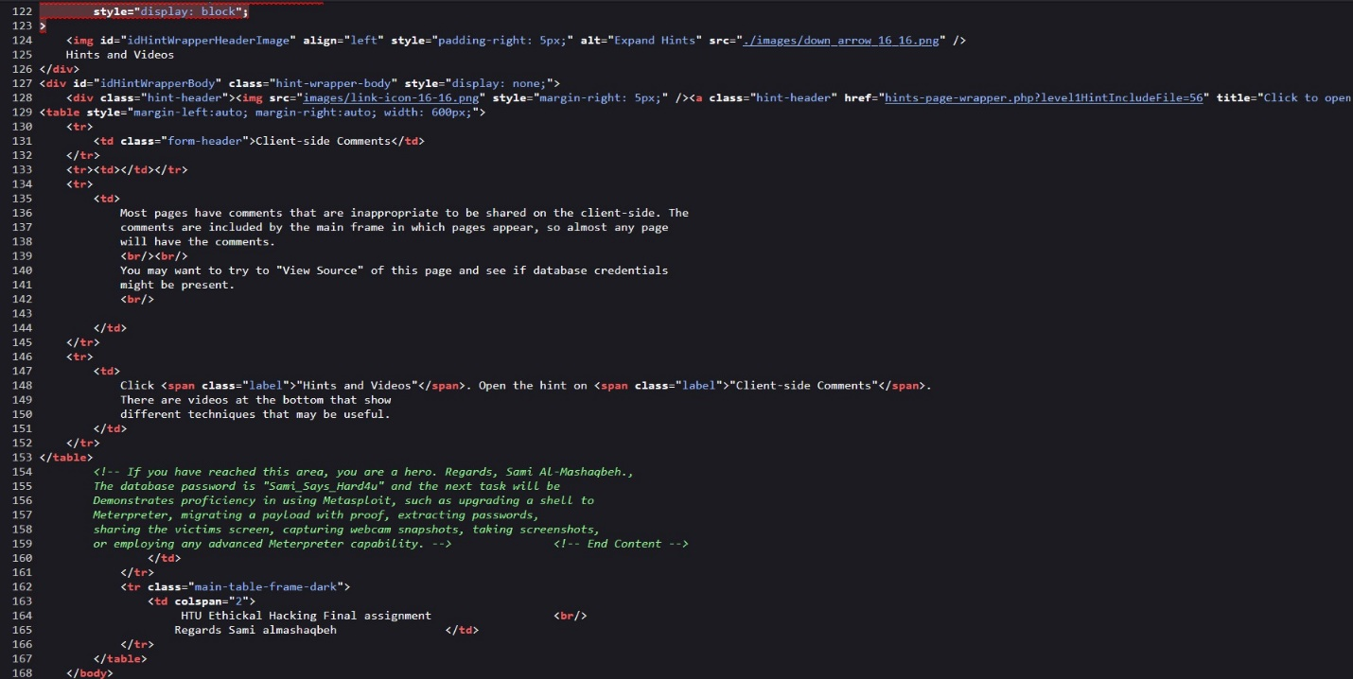

Hamza Osama

### 3.4.3. Identify Broken Access Control, and then log in as the admin user

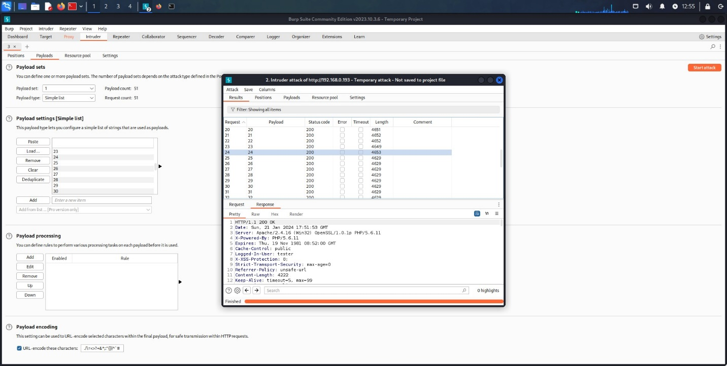

Hamza Osama

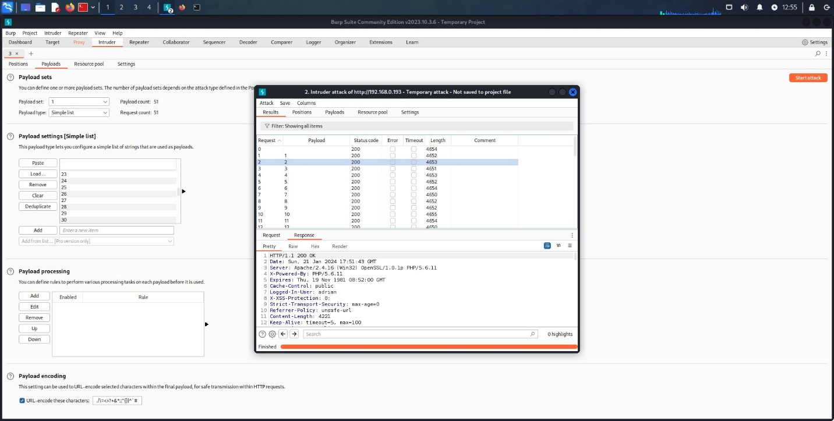

Hamza Osama

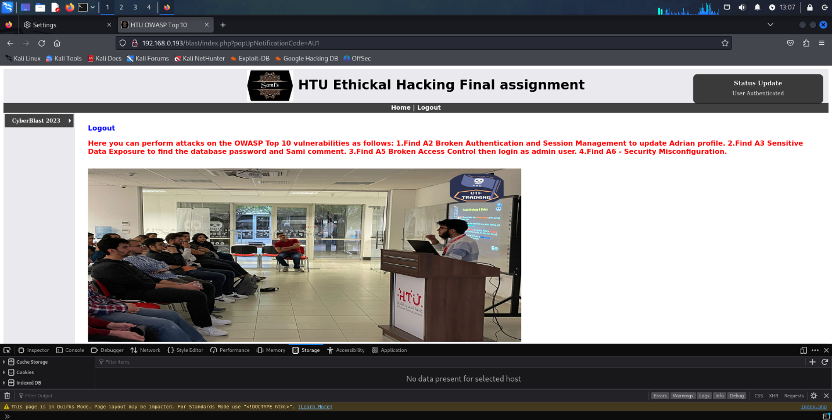

Hamza Osama

### 3.4.4. Security misconfigurations and using Gobuster to list all files and identify the password file

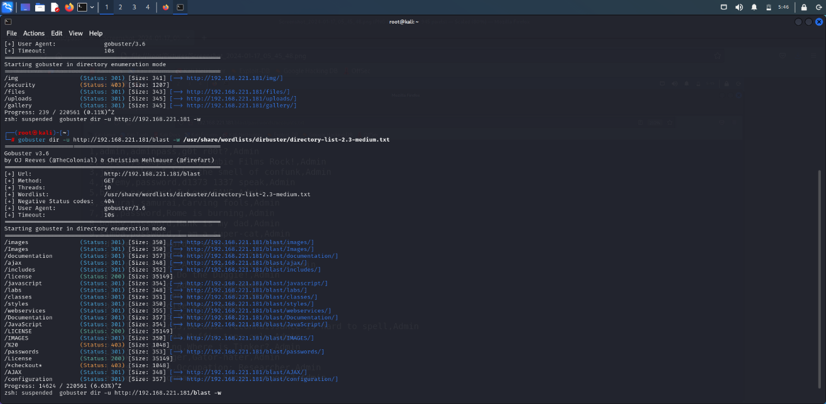

Hamza Osama

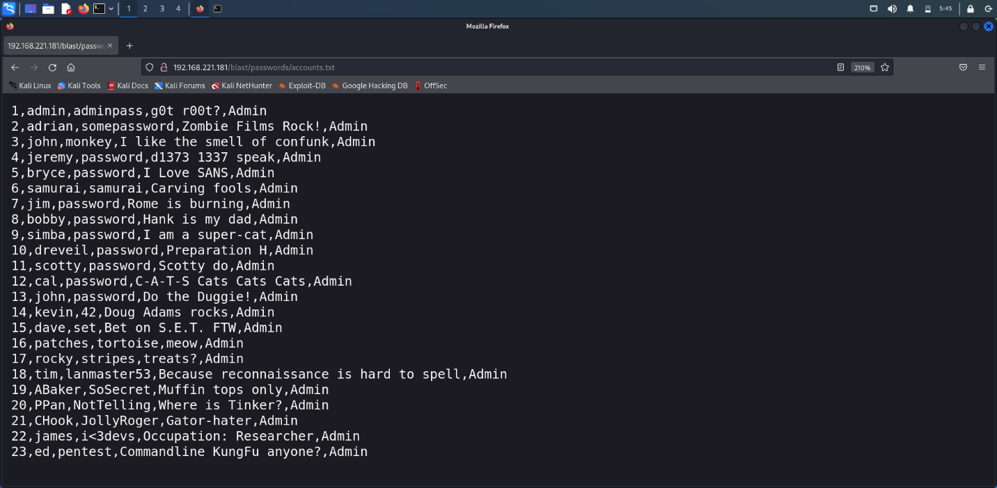

Hamza Osama

## 3.5. The Metasploit framework

3.5.1. Identify the Vulnerable Services 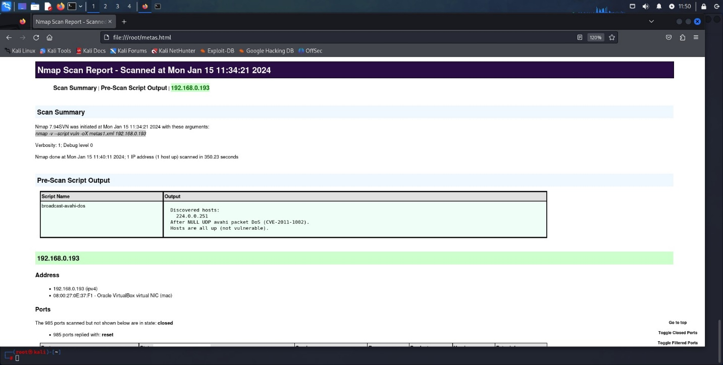

Hamza Osama

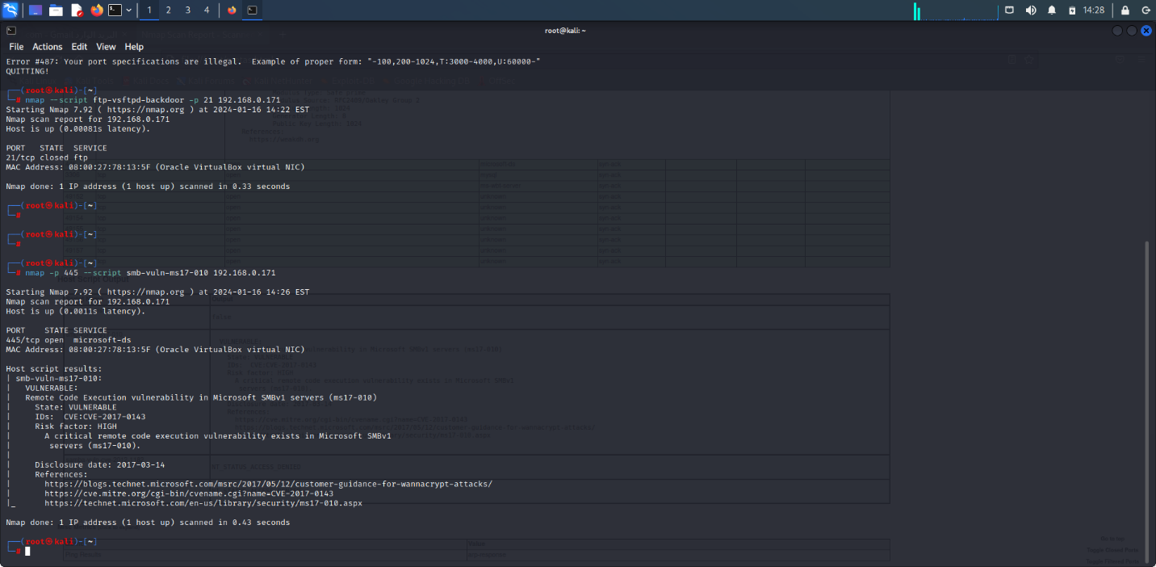

Hamza Osama

3.5.2. Exploit well-known vulnerabilities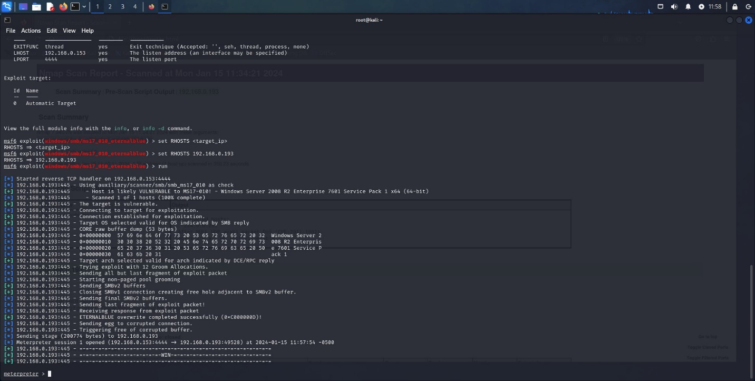

Hamza Osama

3.5.3. Migrate your payload with proof, extracting passwords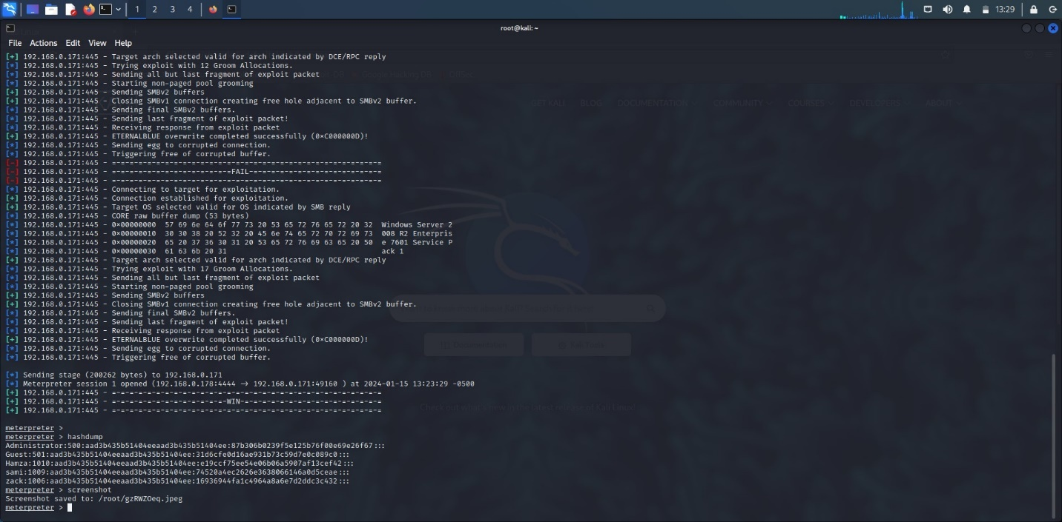

Hamza Osama

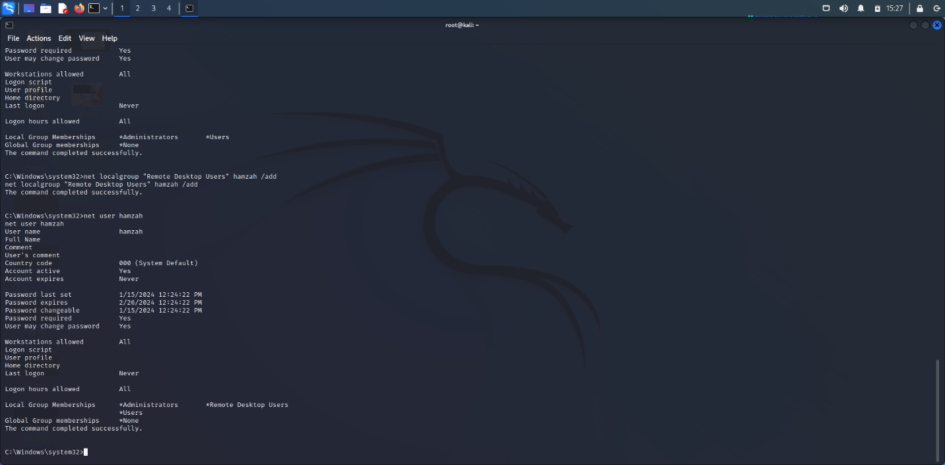

Hamza Osama

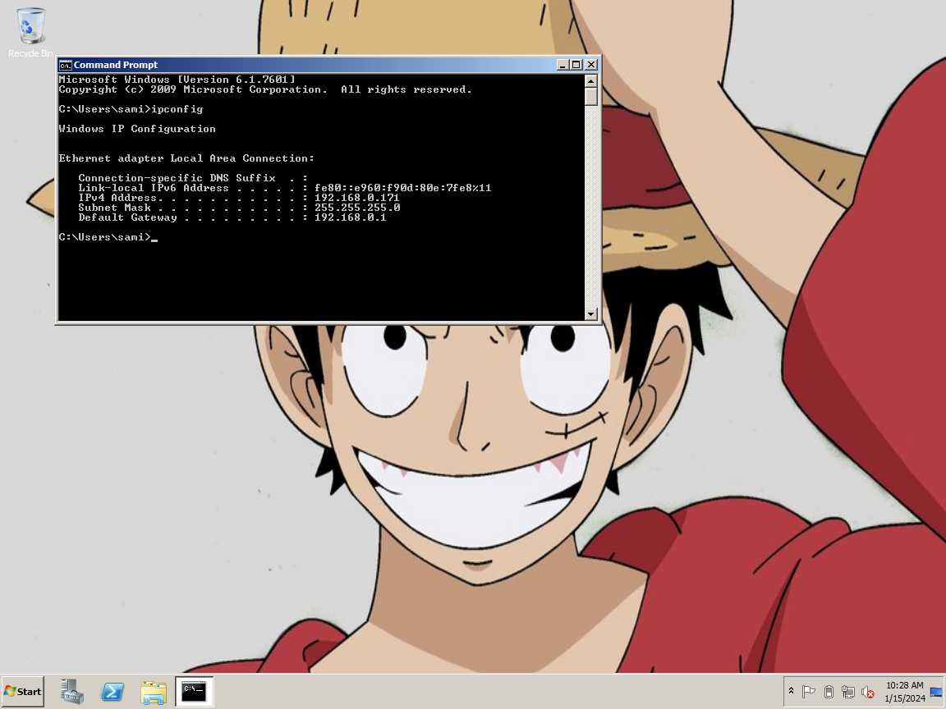

Hamza Osama

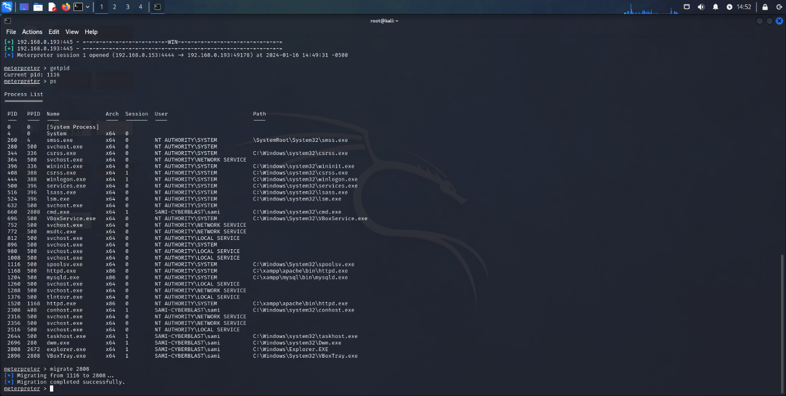

Hamza Osama

### 3.5.4. Create a Username and Add the User to The Local 'Administrator' and 'Remote Desktop Users' Groups. Connect to The Target Machine

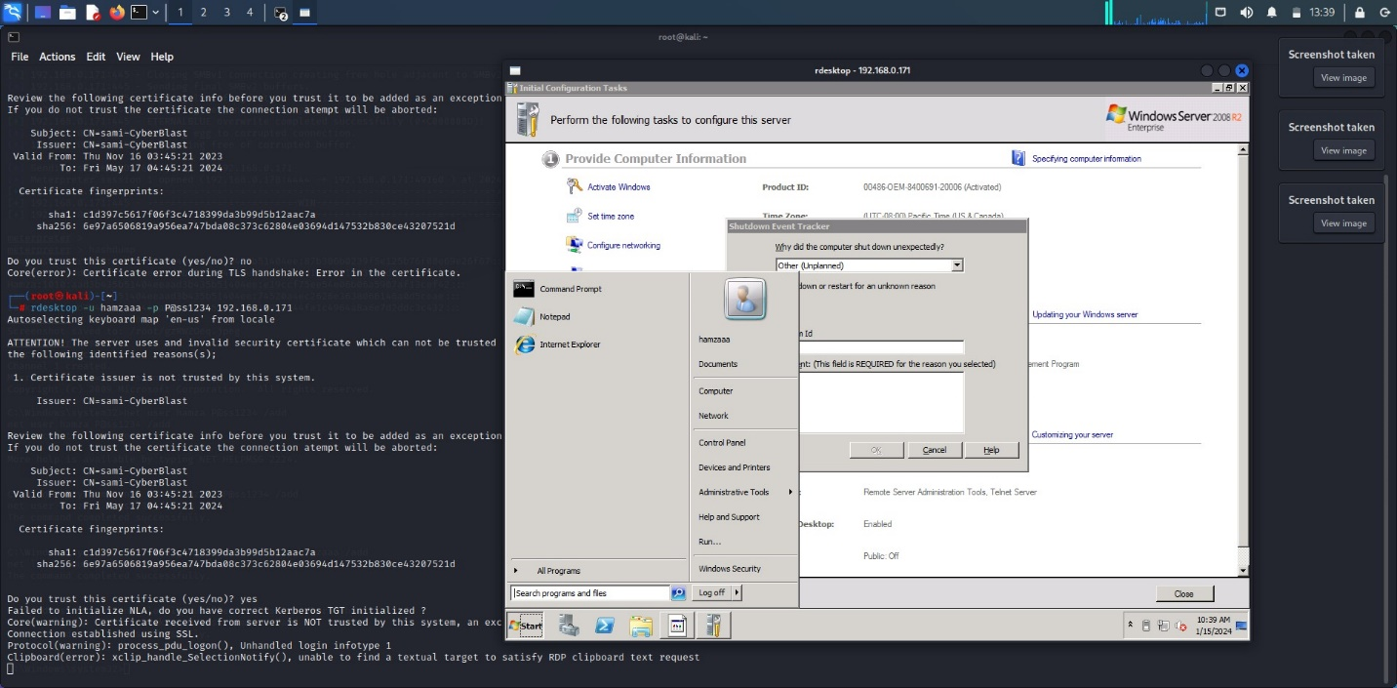

Hamza Osama

### 3.5.5. Utilize the Patch File Located on The Targeted Server Desktop to Address This Vulnerability

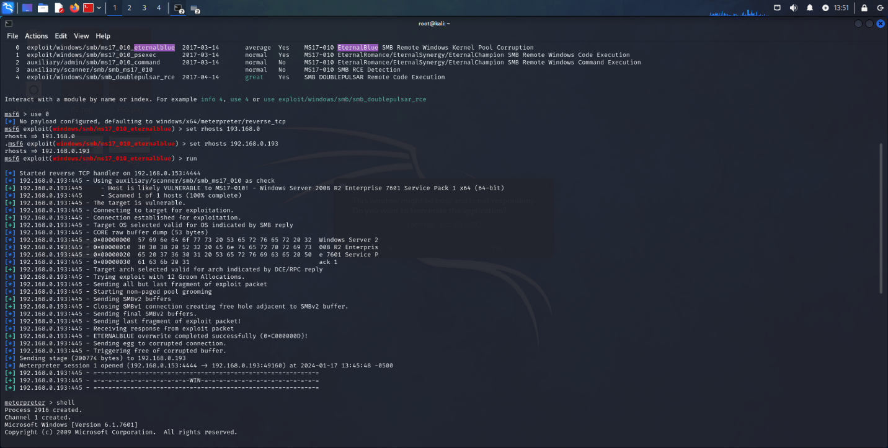

Hamza Osama

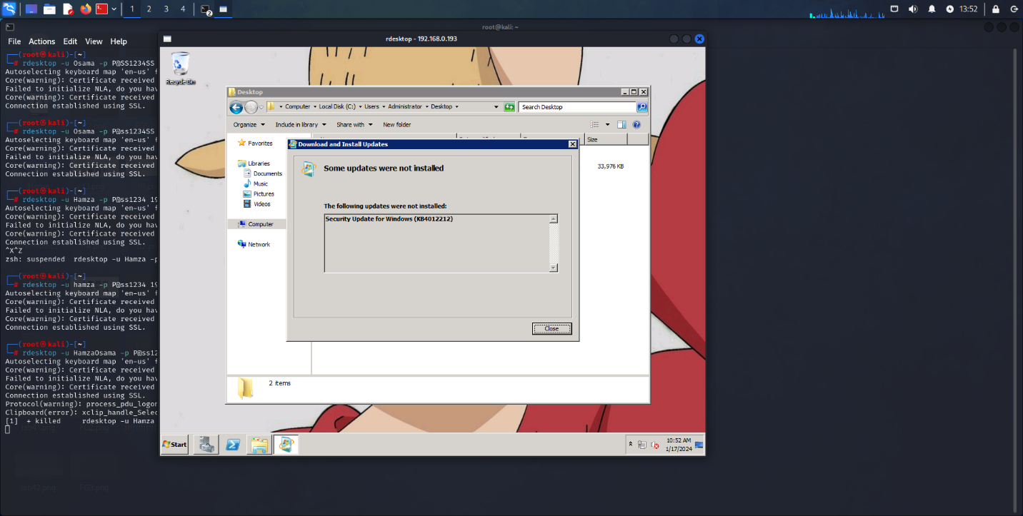

Hamza Osama

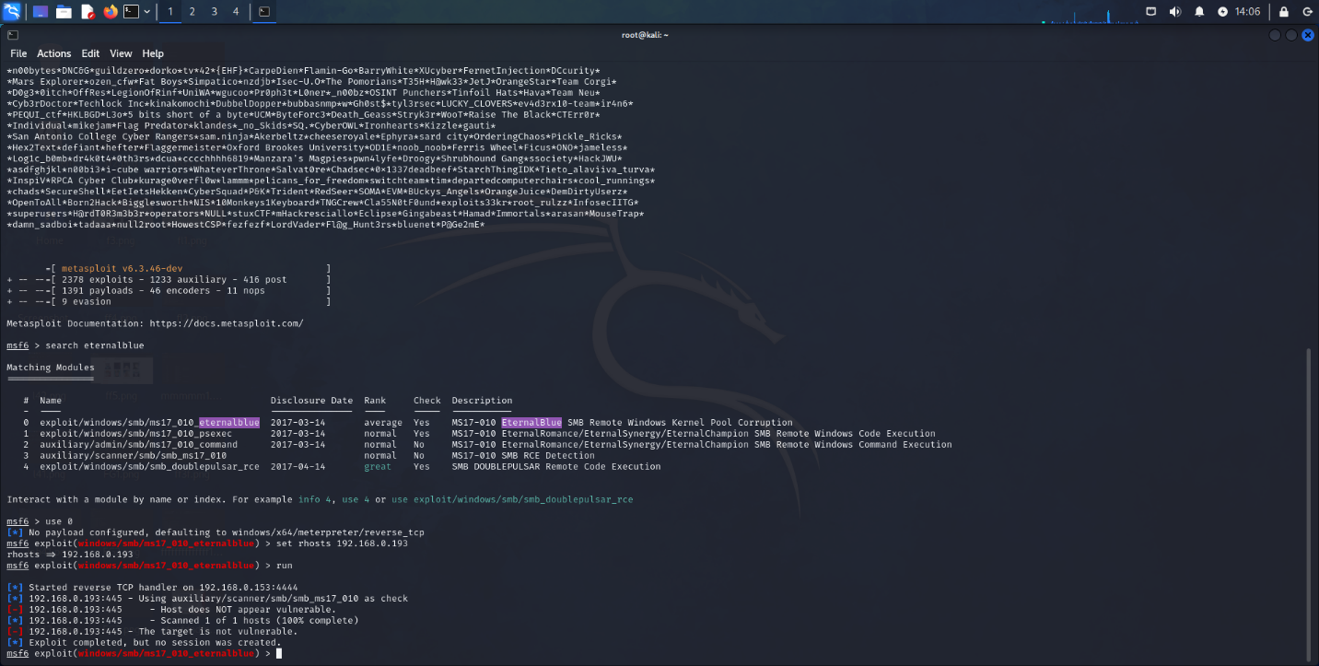

Hamza Osama

### 3.5.6. Exploit Attack to Get Shell and Upgrade It to Meterpreter

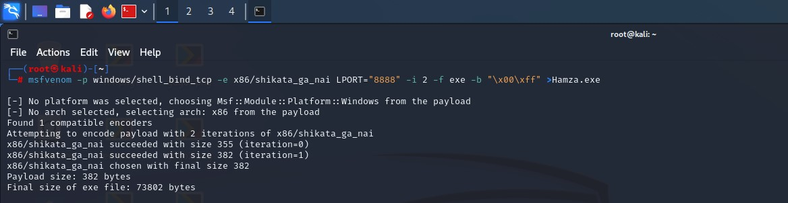

Hamza Osama

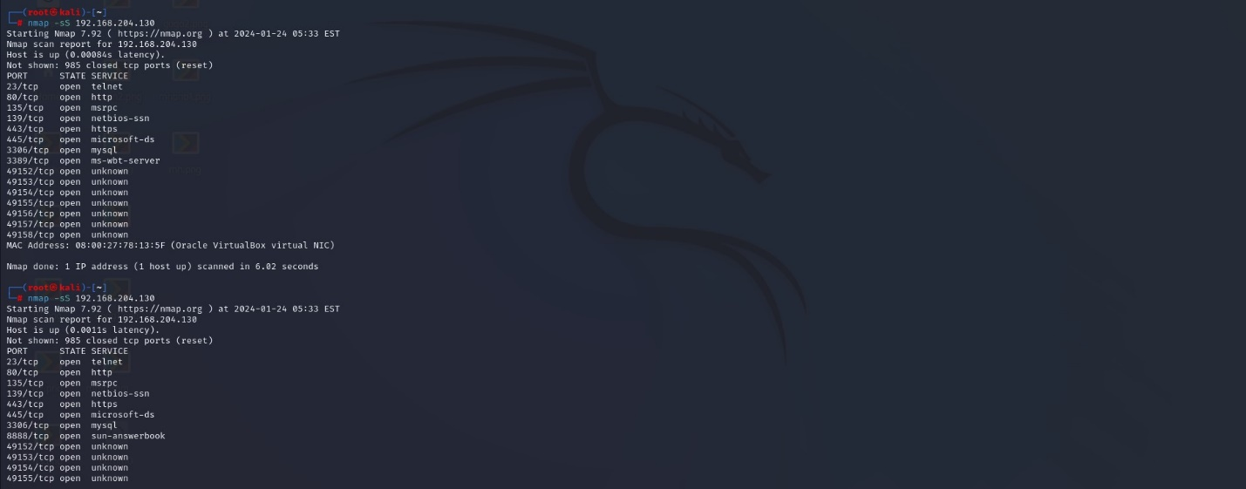

Hamza Osama

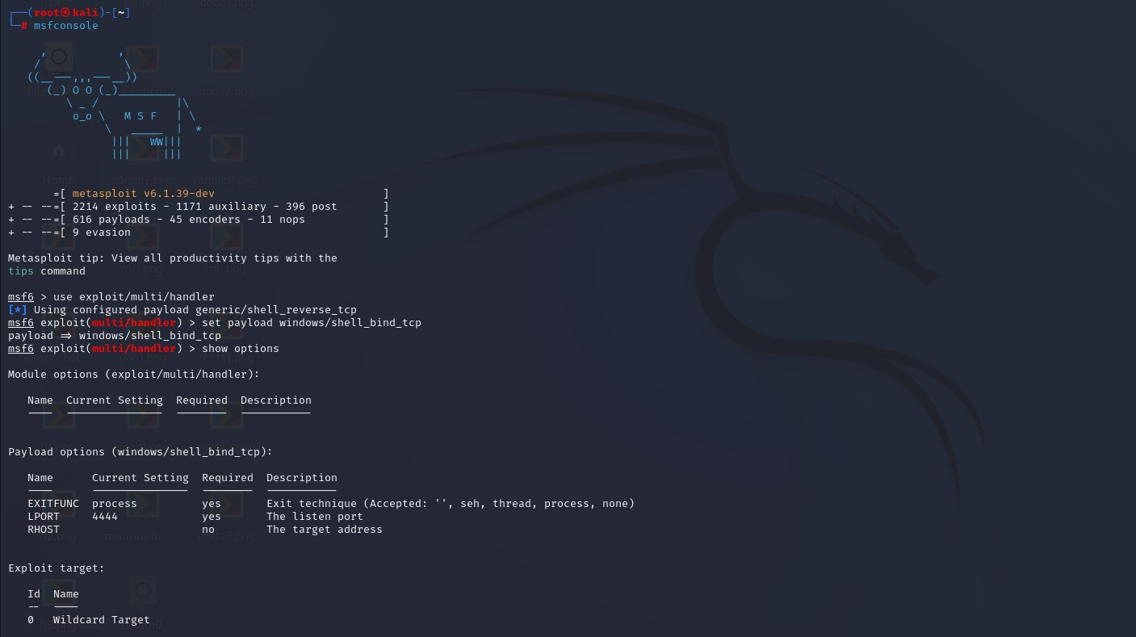

Hamza Osama

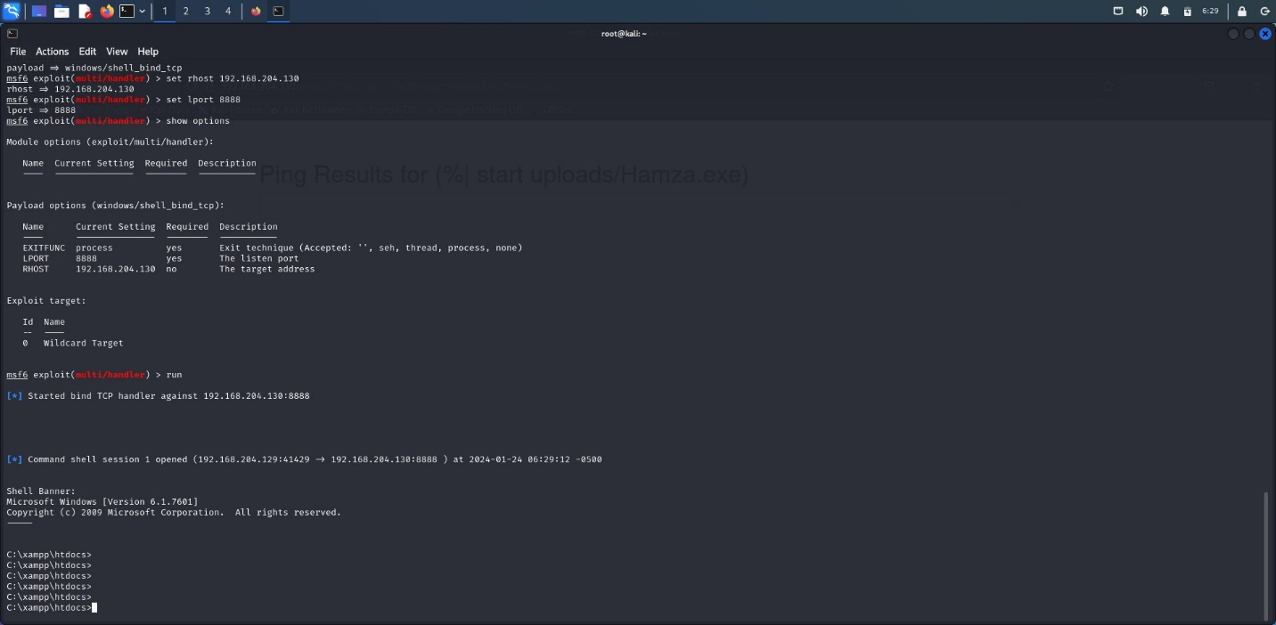

Hamza Osama

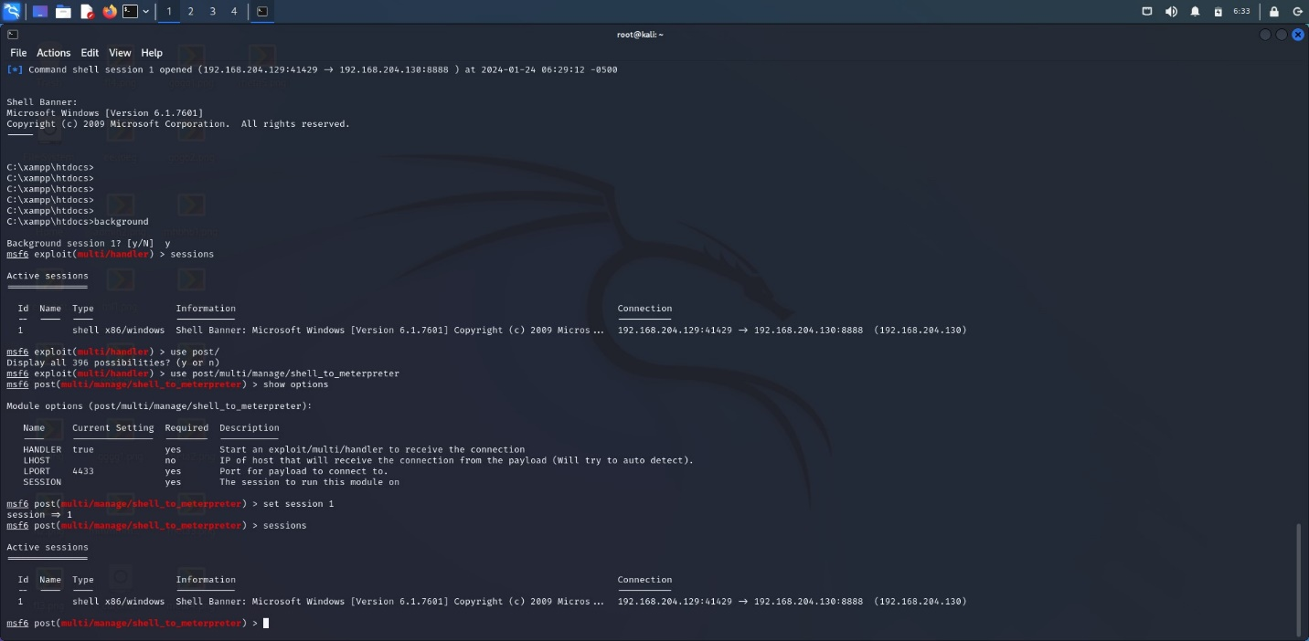

Hamza Osama

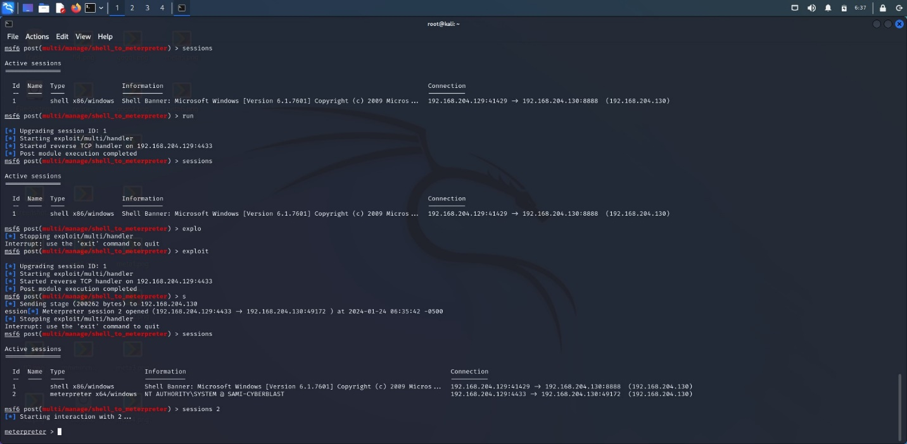

Hamza Osama

References

[0]Singh, S. (2023) *The Importance of Ethical Hacking in Cybersecurity: Protecting Your Systems and Data*, *IFACET*. Available at: <https://ifacet.iitk.ac.in/the-importance-of-ethical-hacking-in-cybersecurity-protecting-your-systems-and-data/#:~:text=It%20involves%20finding%20vulnerabilities%20in,ensuring%20that%20systems%20remain%20secure>. (Accessed: 21 November 2023).

[1]Narang, M. (2023) *Ethical hacking example: 5 times ethical hackers saved the day*, *KnowledgeHut*. Available at: <https://www.knowledgehut.com/blog/security/ethical-hacking-examples> (Accessed: 21 November 2023).

[2] Mishra, V. (2023) The Legal and Ethical Aspects of Ethical Hacking: Understanding Your Responsibilities, IFACET. Available at: <https://ifacet.iitk.ac.in/the-legal-and-ethical-aspects-of-ethical-hacking-understanding-your-responsibilities/> (Accessed: 21 November 2023).

[3] Srivastava, S. (no date) Legal aspects of ethical hacking, Legal Service India - Law, Lawyers and Legal Resources. Available at: <https://www.legalserviceindia.com/legal/article-3395-legal-aspects-of-ethical-hacking.html> (Accessed: 21 November 2023).

[4] What is a whistleblower (2021) National Whistleblower Center. Available at: <https://www.whistleblowers.org/what-is-a-whistleblower/> (Accessed: 21 November 2023).

[5] EC-Council (2023) How to become a certified ethical hacker, CERT. Available at: <https://cert.eccouncil.org/certified-ethical-hacker.html#:~:text=A%20Certified%20Ethical%20Hacker%20is,a%20target%20system(s)>. (Accessed: 21 November 2023).

[6] OSCP explained (2023) infosec. Available at: <https://infosec-jobs.com/insights/oscp-explained/> (Accessed: 21 November 2023).

[7] Shah, A.P. (2023) What is the giac penetration tester (GPEN) certification?, HackerNoon. Available at: <https://hackernoon.com/what-is-the-giac-penetration-tester-gpen-certification> (Accessed: 21 November 2023).

[8] Loshin, P., Teravainen, T. and Tittel, E. (2022) What is Certified Information Systems Security Professional (CISSP)?: Definition from TechTarget, Security. Available at: <https://www.techtarget.com/searchsecurity/definition/Certified-Information-Systems-Security-Professional> (Accessed: 21 November 2023).

[9] CISSP - certified Information Systems Security professional (no date) ISC2. Available at: <https://www.isc2.org/certifications/cissp> (Accessed: 21 November 2023).

[10] Elearnsecurity Certified Professional Penetration Tester (ECPPTV2): Certifications (no date) INE. Available at: <https://ine.com/learning/certifications/external/elearnsecurity-certified-professional-penetration-tester> (Accessed: 21 November 2023).

[11] Institute of Advanced Technologies. Available at: <https://iat.edu.mm/courses/cybersecurity/elearnsecurity-certified-professional-penetration-tester-ecpptv2-course/> (Accessed: 21 November 2023).

[12] Banu (2023) What’s the difference between ethical hacking and penetration testing?, Cybersecurity Exchange. Available at: <https://www.eccouncil.org/cybersecurity-exchange/ethical-hacking/ethical-hacking-vs-penetration-testing/> (Accessed: 22 November 2023).

[13] What is Vulnerability Assessment: VA Tools and Best Practices: Imperva (2023) Learning Center. Available at: <https://www.imperva.com/learn/application-security/vulnerability-assessment/> (Accessed: 22 November 2023).

[14] Professionals, T.I. for (2023) Ethical hacking 101: 5 times they saved the day, https://www.insightsforprofessionals.com. Available at: <https://www.insightsforprofessionals.com/it/security/examples-of-when-ethical-hackers-save-day> (Accessed: 22 November 2023).

[15] Blogger (2023) Penetration testing success stories: Real-world example: TFT, Think Future Technologies. Available at: <https://www.tftus.com/blog/real-world-examples-of-penetration-testing> (Accessed: 23 November 2023).

[16] The heartbleed bug: How a flaw in openssl caused a security crisis (2022) CSO Online. Available at: <https://www.csoonline.com/article/562859/the-heartbleed-bug-how-a-flaw-in-openssl-caused-a-security-crisis.html#:~:text=Heartbleed%20is%20a%20vulnerability%20in,Sockets%20Layer%20(SSL)%20protocol>. (Accessed: 23 November 2023).

[17] William, W. (2023) Web application architecture: The latest guide 2024, ClickIT. Available at: <https://www.clickittech.com/devops/web-application-architecture/> (Accessed: 05 December 2023).

[18] Web application architecture - detailed explanation (2022) InterviewBit. Available at: <https://www.interviewbit.com/blog/web-application-architecture/> (Accessed: 05 December 2023).

[19] What is TLS (Transport Layer Security)? - cloudflare. Available at: <https://www.cloudflare.com/learning/ssl/transport-layer-security-tls/> (Accessed: 05 December 2023).

[20] What is HTTP? | cloudflare. Available at: <https://www.cloudflare.com/learning/ddos/glossary/hypertext-transfer-protocol-http/> (Accessed: 05 December 2023).

[21] Zhong, W. Command injection, Command Injection | OWASP Foundation. Available at: <https://owasp.org/www-community/attacks/Command_Injection#:~:text=Command%20injection%20is%20an%20attack,.)%20to%20a%20system%20shell> (Accessed: 05 December 2023).

[22] KirstenS., Cross site scripting (XSS), Cross Site Scripting (XSS) | OWASP Foundation. Available at: <https://owasp.org/www-community/attacks/xss/> (Accessed: 05 December 2023).

[23] *What is cross-site request forgery (CSRF) and how does it work?* (no date) *Synopsys*. Available at: <https://www.synopsys.com/glossary/what-is-csrf.html#:~:text=Cross%2DSite%20Request%20Forgery%20(CSRF)%20is%20an%20attack%20that,has%20in%20an%20authenticated%20user> (Accessed: 05 December 2023).

[24] Simplilearn, S. (2023) What is Metasploit: Overview, framework, and how is it used: Simplilearn, Simplilearn.com. Available at: <https://www.simplilearn.com/what-is-metaspoilt-article> (Accessed: 05 December 2023).

[25] What is metasploit: Tools &amp; Components explained: Imperva (no date) Learning Center. Available at: <https://www.imperva.com/learn/application-security/metasploit/> (Accessed: 05 December 2023).